. | The Feeder |  |  |  | September 2022

office project complete and moved in!
We have been extremely busy these past couple of weeks working on all the finishing details of our office project, and are very excited to announce that we are now fully complete and moved back into our main office! While we have a few remaining details left in the kitchen area and many boxes to unpack and organize yet, we are now in full operation mode in our office, rest room, storage room, and break room areas. We completed this extensive project from start to finish in only 3 months and 3 weeks! While we did have many contractors assist us with this project on a professional level, we did do a LOT of the carpentry work ourselves. Fortunately, we have some very skilled employees, which kept this project on time!  Our newly renovated office has not changed overall size, however, the new and improved layout greatly increased the space efficiency. Due to this, we now have additional retail shelfing space so we can have more organized retail products and expanded retail line. We also have far more desk space for our 5 office employees, with a very organized layout that accomodates multiple haulers, customers, and visitors at once. We have more than doubled our service counter area as well. Our new rest room now includes three stalls, lockers for production employees, washer/dryer, storage, and even a shower room! |  | 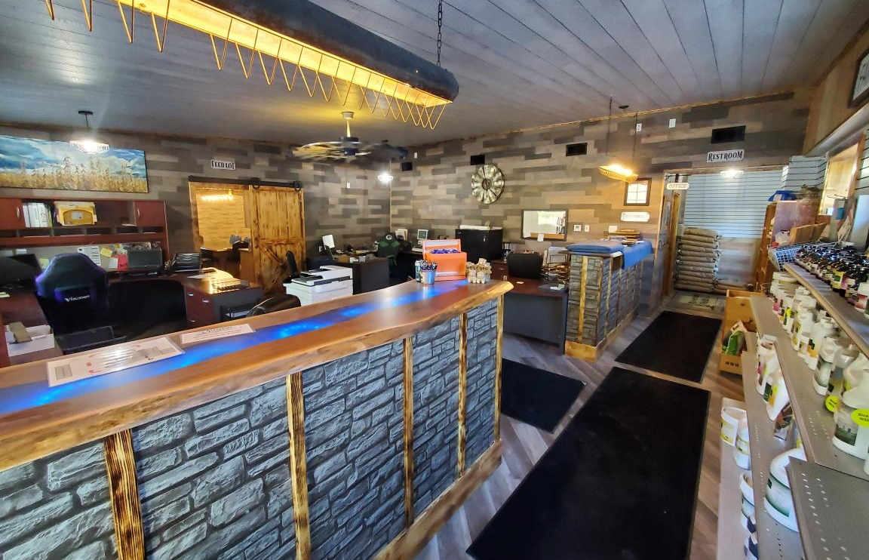  Our storage room has doubled in size, allowing for multiple years worth of growth for all of our historic documents that legally need to be stored. This locked storage room also houses all of our marketing products and equipment, and our technology server system that powers all of our computers, phones, printers, and security cameras.  The new break room, also known as “Feed Lot”, contains our 10 seat break table for employee breaks and meetings. This room includes a smart TV and a white board for business functions. Since this is the employee break room, there is also a full size brand new kitchen with all new appliances. Amanda Frantzen will be offering lunch specials a few times a week for our hard working employees, which explains why we are calling this room “Feed Lot”! Now that the office project is complete, we are moving onto finishing our new bagging room. We expect to finish this in September!  You may see on the price list that a lot of products are marked as “Limited” or “OUT”. Please keep in touch with our staff on your upcoming needs. |  |  | equipment  for sale:  center dump gravity wagons  Since we have greatly increased our raw ingredient storage and handling systems recently, we are offering for sale 2 Killbros center dump gravity wagons with Westendorf running gears and roll tarps. These wagons are twins in very nice condition including: 8 ton Westendorf running gear, 2 bottom doors that are center dump (NOT side dump), all metal box, roll tarp with crank handle. These wagons hold about 300 bushels each. Since we are not using them, they are available to look at and purchase anytime. If you have a drive over pit, or wish to use these wagons to haul grain to your local elevator, they would work great. Asking $900/each.  We also have a BRAND NEW Smidley hog scale with digital head for sale! This scale is available for $2800. We have a very nice condition Smidley hog head chute/processing chute. This classic item is in very nice condition, asking $950 obo.  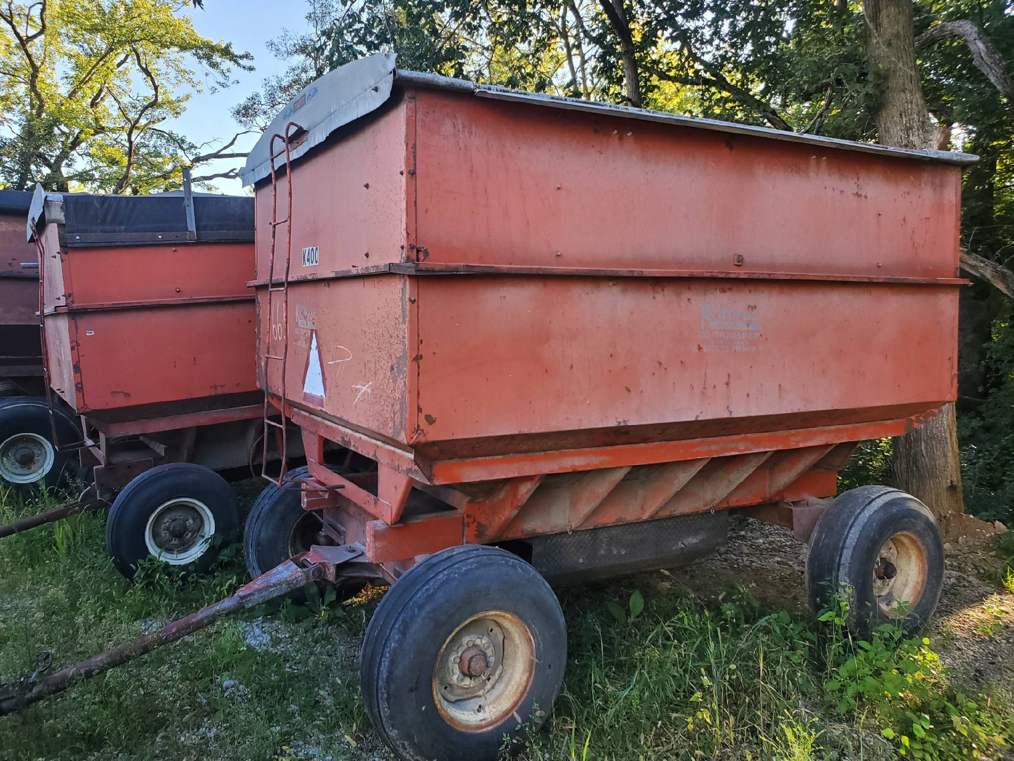

Warehouse offerings!
CONTACT US!
300 Forest Street
Riceville, IA 50466
641-985-2494 Office
riversidefeeds@gmail.com
www.riversidefeeds.net
Current specials of available supplies. Please refer to enclosed Price List for all products. All items/products are FOB Riceville, IA. Please call to verify availability on all products. Customer pickup or delivery of products can be arranged anytime. |  |  |  |  |  | ORGANIC GRAIN PRICES:  *Upper Midwest References – NOT Riverside Feeds Offers  Corn: $11.00 / Bu  Soybeans: $37.00 + / Bu Feed, $39.00 + / Bu Food  Wheat: $12.00 / Bu  Barley: $12.00 / Bu  Oats: $10.00 / Bu  Soybean Meal: $1800 / Ton +
Smidley Livestock Waterer Equipment: single, double, and triple hog drinking bars and scales available in used, refurbished condition.  Smidley used equipment special: Hog, Sheep, Goat portable head chute! A great condition oldie. Asking $950 OBO. Digital head hog scale - $2800. |  |  | Organic Soybean Oil – Available in 1 ton liquid totes for $0.85 / #. Currently have 2 totes available.  Non-GMO & Organic Oat Mill Run Pellets – 50 pound sacks, totes, or bulk. Supply is readily available!  Organic Steamed Rolled Oats – Available in 2,000# totes or bulk. $1000 / ton.  EXPANDED Retail Shelf: Smidley, Crystal Creek, Fertrell, Redmond Agriculture, Redmond human & hunt products, Dr. Paul’s Lab, Dr. Sarah’s Essentials, Pyganic, Apple Cider Vinegar – For humans and animals!  Full Warehouse selection of vitamins, minerals, and ingredients! Ingredient prices have been going up, so stock up now to save money.
FUTURE EVENTS:
- We will be CLOSED in observance of Labor Day on Monday, September 5th, 2022. Please plan accordingly, and we will be open normal business hours on Tuesday, September 6th.
- Our newly renovated Office, Break Room, Storage Room, and Rest Room are fully complete and ready for business! Stop by, check out our renovations, and enjoy! We are very excited to be able to work in a very comfortable environment and would love to show it to you! We will be focusing on finishing our new bagging room, which will be a climate-controlled room for employee comfort, and an increase of our production efficiencies throughout the month of September.
Keeping COVID-19 concerns in mind, please do NOT enter our premises if you are feeling ill or recently tested positive for COVID-19. Our office doors are OPEN to the public.
- PLEASE NOTE - Office Hours: Monday – Thursday: 8 am – 5 pm. Friday: 8 am – 4 pm.
Seasonal Products:

Non-GMO Swine Feeds – Hog Starter/Grower pellets for $16 / 50# bag, and Hog Grower/Finisher pellets for $13 / 50# bag
Redmond Trophy rock ($15 / 20#) and Bomb Pellets (Cherry or Apple flavor - $14 / 20# bag) for wildlife growth and development. Redmond Apple or Cherry Spray for $14. Riverside’s Wildlife Feed freshly made for $10 / 50# bag.

