. | The Feeder |  |  |  | August 2023

10 Year anniversary open house august 4
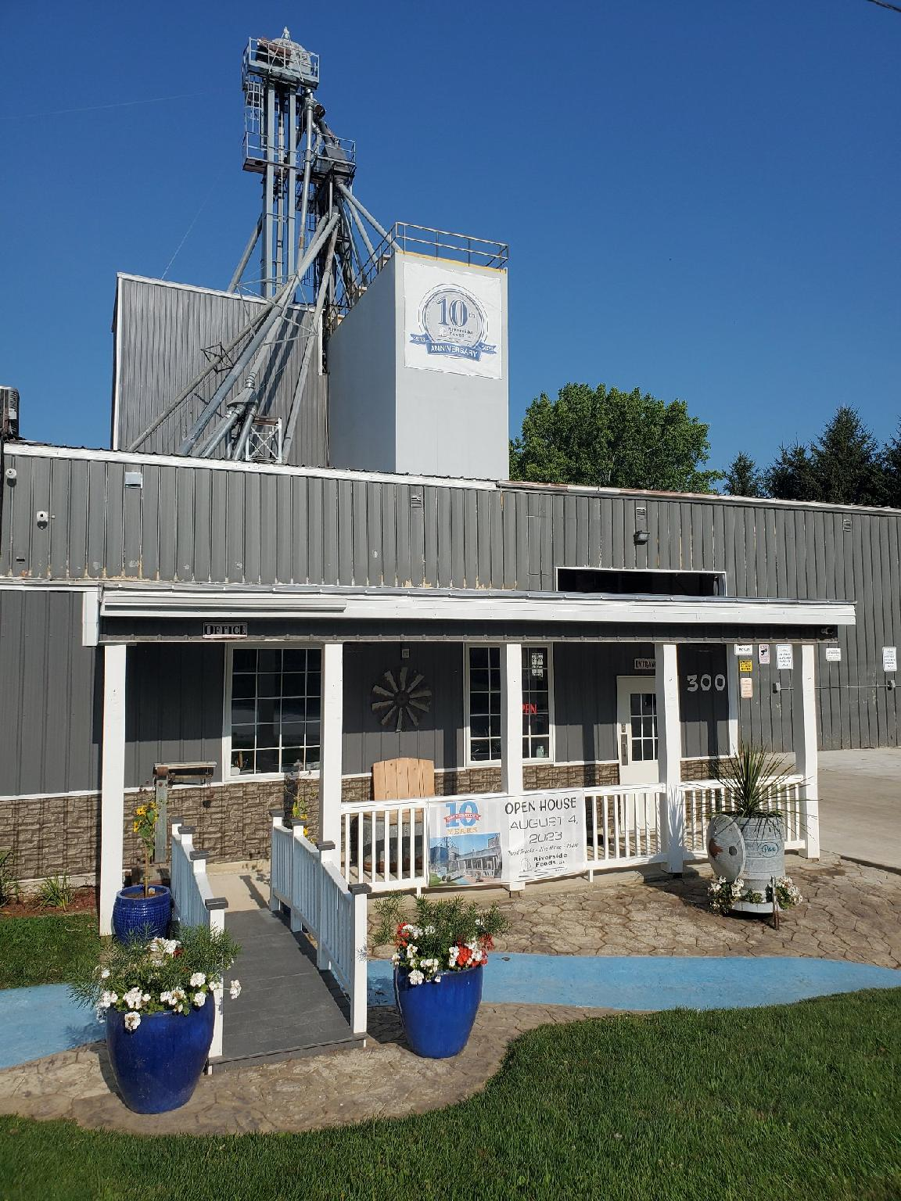  We are very excited to host our 10 Year Anniversary Open House on Friday, August 4th, and hope to see you present! We will have live music, food trucks, beverages, ice cream, drawings and door prizes, guided plant tours, meet the staff, yard games, and much more in order to make this open house fun for all ages! This is open to all public, and RSVP’s are not required. We decided that hosting a fun filled afternoon would provide the chance for our loyal customers, haulers, vendors, and supporters to come in, see what we’ve built, and learn a little more about us. Thinking back over the past ten years, we seriously have been under constant construction since day one. When I purchased “Forest Street Plant”, it was just an empty, dirty warehouse with loads of potential and dreams. Little did I know just what the next ten years had in store! The best way to describe the amount of business buildup and construction was to make a list for you to read: |  | 10 Year Anniversary  Open House  Friday, August 4th, 2023  1:00 PM – 6:00 PM  300 Forest Street  Riceville, IA 50466  Riverside Feeds Timeline:  January 2013 – Formed and started official business  February 2013 – Purchased Forest Street Plant (empty warehouse)  March 2013 – Starting grinding soy byproducts with tractor and hammermill at new location  December 2014 – Built first stationary feed mill (grind & mix)  January 2016 – Merged Frantzen Farm Feeds with Riverside Feeds  July 2016 – Broke ground on 9 month long pellet mill project  March 2017 – Finished new pellet mill addition, started pelleting  April 2019 – Added more finished pellet overhead bins  June 2020 – Overhauled feed mill with larger hammermill and new layout for efficient operations  October 2021 – Added more finished pellet overhead bins  November 2021 – Added 80’ receiving tower and overhead feed mill bins  May 2022 – Added 2 cone bottom grain bins for feed mill  June thru October 2022 – Remodeled entire office, break room, rest room, and built new tote and sack filling lines  2013 – Celebrated 10 successful years in business serving over 700 active customers and over 34,000 tons of Non-GMO and Organic feed products per year! |  | 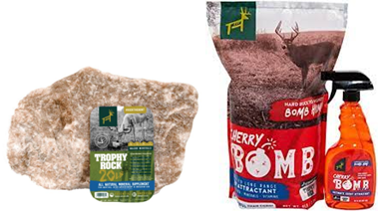 | Redmond hunt products  Needing some wildlife products to help promote habitat and antler growth? Now is the time of the year to have your wildlife products placed in your favorite wooded areas. We carry Redmond Hunt products which include Trophy Rock (salt rock), Apple or Cherry Bomb Pellets, Apple or Cherry Bomb Spray (scent spray), plus we also produce our very own Non-GMO Wildlife Feed Pellets!  Trophy rock has proven to assist deer with their salt and mineral demands. With trophy rock, antlers have grown faster and larger due to proper mineral balances in the deer’s diet. Simply place the trophy rock in a common deer crossing or living area, or on a tree stump.  Redmond Hunt Products:  - 20# Trophy Rock $15  - 16 oz Bomb Spray $14  - 20# Bomb Pellets $14  - 40# Bomb Pellets $22

Warehouse offerings!
CONTACT US!
300 Forest Street
Riceville, IA 50466
641-985-2494 Office
riversidefeeds@gmail.com
www.riversidefeeds.net
Current specials of available supplies. Please refer to enclosed Price List for all products. All items/products are FOB Riceville, IA. Please call to verify availability on all products. Customer pickup or delivery of products can be arranged anytime. |  |  |  |  |  | ORGANIC GRAIN PRICES:  *Upper Midwest References – NOT Riverside Feeds Offers  Corn: $10.50 / Bu  Soybeans: $22.00 + / Bu Feed, $28.00 + / Bu Food  Wheat: $9.00 / Bu  Barley: $7.00 / Bu  Oats: $4.50 / Bu  Soybean Meal: $1150 / Ton +
Smidley Livestock Waterer Equipment: single, double, and triple hog drinking bars and scales available in used, refurbished condition.  Seasonal Products:  Non-GMO Swine Feeds – Hog Starter/Grower pellets for $17 / 50# bag, and Hog Grower/Finisher pellets for $14 / 50# bag  Non-GMO Chick Starter Crumbles still available! $22 / 50# bag. Also have Non-GMO Layer Feed Pellets and Broiler Grower Pellets available at $18 / 50# bag. SunCoast Pine Shavings for $9 / 12 cubic foot bag. Stock up now for your flock!  Smidley used equipment special: Hog, Sheep, Goat portable head chute! A great condition oldie. Asking $950 OBO. Also have 2 hog scales available. |  |  | Organic Prewean 22 – This swine feed is made for young pigs to start on dry creep feed prior to weaning. $34 / 50#  Organic Opro 40 Soy Protein – Available either bulk or 2,000# totes. $950 / ton. Organic Okara Soy Protein – bulk or totes $1,000 / ton.  Non-GMO Rumapro Soy Hull Pellets - $250 / ton, available bulk or tote. Sacks can also be made available.  Organic Steamed Rolled Oats – Available in 2,000# totes or bulk. $1000 / ton.  EXPANDED Retail Shelf: Smidley, Crystal Creek, Fertrell, Redmond Agriculture, Redmond human (Real Salt & Re-Lyte) & hunt products, Dr. Paul’s Lab, Dr. Sarah’s Essentials, Pyganic, Apple Cider Vinegar – For humans and animals!
FUTURE EVENTS:
- Riverside Feeds 10 Year Open House – Friday, August 4th, 2023, 1 pm – 6 pm, in Riceville, IA. Will include Food Trucks, Mill Tours, LIVE MUSIC, Beverages/Ice Cream, & Giveaways! Open to all public! *Please note that we will NOT be loading any feed products out during the open house.*
- Our last local summer town parade will be at Wapsi Days Parade in Riceville, IA, on Saturday, August 5th at 6:00 PM. Since this is our local community, we are planning on having a very large parade float to help celebrate our 10 years in business!
- We will be CLOSED on Friday, August 11th (all trucks, mills, and office) so our hard-working staff can take the day off and enjoy our ‘Summerfest’ outing! This year, we will be heading to the Iowa State Fair to partake in the enjoyment that the fair has to offer! Please plan accordingly, will be open normal times the following week.
- PLEASE NOTE - Office Hours: Monday – Thursday: 8 am – 5 pm. Friday: 8 am – 4 pm.

