 | The Feeder |  |  |  | August 2021

notice: closed all day on August 20th
This year marks our 8th year in business! After all these years of start up and multiple expansions and annual record growths, we have decided to take a day off for a full team professional development day! Yes, we will be sitting back and relaxing, but we will also be spending the day with some VIP’s in our business trade and making long lasting connections even stronger! We will be heading to LaCrosse, WI, for our “Summerfest” outing. Please note: We will be CLOSED ALL DAY on Friday, August 20th (this includes all team members, office & production). Please make note of this, as we will not be answering any phone calls, walk in customers, nor will we be delivering any feed. Please treat this the same as a holiday, so make sure all orders are in earlier that week. We are only asking for one additional day off throughout this entire year, so I think we can all pull together and give these hard working team members a much needed break. THANK YOU!  We decided recently to try to spruce up our direct marketing efforts a bit, and after years of discussing, we have finally introduced our first custom printed feed sack to our product line up! Our Oat Mill Run Pellets are now in custom printed Riverside Feeds sacks (at no additional cost to you). These sacks look better, and will help identify our Oat Mill Run Pellets! |  | Supply Challenges  Supply imbalances can be the most stressful problems we face in this business and hard to predict. We went from long on our main products (Oat Mill Run Pellets and Soy Hull Pellets) to very short due to high demand and low production rates of the raw materials from our vendors. Unfortunately, this summer has been incredibly challenging for us to meet and fulfill all orders due to these swings. Please notify us as far in advance as possible so we can do our best to meet your demands, while we hope for more supply to become available soon!  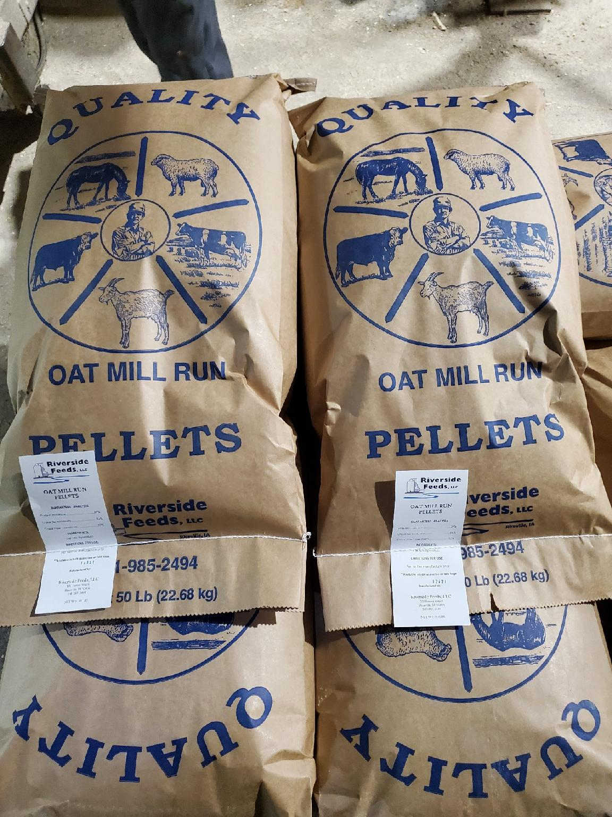  Short on bedding this summer? For a limited time only, we have up to 11 ton of Oat Fiber available in either 50# sacks, tote bags, or bulk. This product is a fine flour, so it is not the easiest to handle, however, it soaks up moisture VERY well if used with coarse materials like straw or stalks. Call today to ask for more info! |  |  | Dr. Sarah’s Essentials Hand sanitizer:  We stock and carry Dr. Sarah’s Essentials Hand Sanitizer in multiple sizes. This alcohol based sanitizer is loaded with essential oils that does not only offer a great smell, but also moisturizes your skin. If you have dry skin problems, I highly recommend using this generously on your hands as a conditioner.  Keeping your hands and skin moist will help keeping viruses and infection from seeping into your system through cracked skin. That is why it is highly recommended to use hand sanitizer but also moisturizer to fend off COVID-19 and other flu bugs.  We have both liquid and gel form hand sanitizer available in the 8 ounce size. We have liquid available in 8 ounce, 16 ounce, 32 ounce, and 1 gallon refill jug.  Dr. Paul’s Lab Summer Newsletter: Please see enclosed newsletter from Dr. Paul’s Lab! Read about suggestions to keep up with herd health issues during the summer months. We proudly stock most of the products he discusses in the newsletter, especially fly control products. Also note Dr. Paul’s Lab product changes coming soon!

Warehouse offerings!
CONTACT US!
300 Forest Street
Riceville, IA 50466
641-985-2494 Office
riversidefeeds@gmail.com
www.riversidefeeds.net
Current specials of available supplies. Please refer to enclosed Price List for all products. All items/products are FOB Riceville, IA. Please call to verify availability on all products. Customer pickup or delivery of products can be arranged anytime. |  |  |  |  |  | ORGANIC GRAIN PRICES:  *Upper Midwest References  Corn: $9.50 / Bu  Soybeans: $27.50 / Bu Feed, $29.50 / Bu Food  Wheat: $8.00 / Bu  Barley: $8.00 / Bu  Oats: $5.50 / Bu  Soybean Meal: $1300 / Ton
Smidley Livestock Equipment: single, double, and triple hog drinking bars & hog scales available in used, refurbished condition.  Seasonal Products:  SunCoast Pine Shavings – Keep your critters well bedded and warm! $8 / 25# bag  Non-GMO Chick Starter Crumbles – STILL ON HAND! $18 / 50# bag!  Non-GMO Oat Fiber for bedding use only – Available in 50# bags, totes, or bulk. Blend with coarse bedding to absorb moisture. $150 / ton. LIMITED TIME ONLY!  Organic Oat Mill Run Pellets – can be offered in sacks or totes, but currently available in bulk. $200 / ton bulk. |  |  | Organic Steamed Rolled Oats – either 50 pound sacks, or 1600 pound totes, $900 / ton.  Non-GMO Oat Mill Run Pellets – 50 pound sacks, totes, or bulk. CALL FIRST – Supply is rebounding, but please double check!  Non-GMO Pig Starter/Grower, and Non-GMO Hog Grower/Finisher in 50 pound sacks in stock.  Retail: Smidley, Crystal Creek, Fertrell, Redmond Agriculture, Dr. Paul’s Lab, Dr. Sarah’s Essentials, Pyganic, Apple Cider Vinegar – For humans and animals!  Full Warehouse selection of vitamins, minerals, and ingredients! Ingredient prices have been going up, so stock up now to save money.
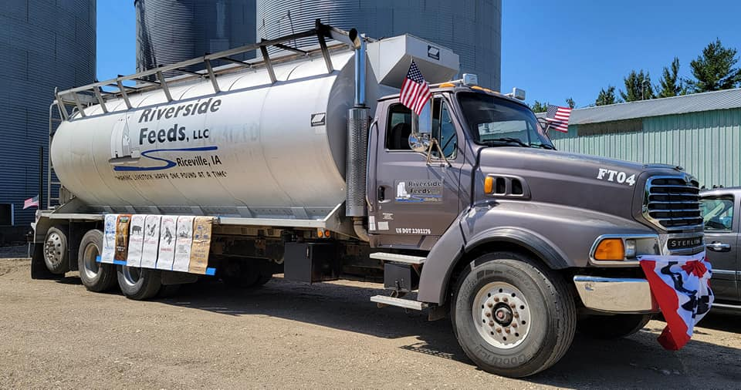
FUTURE EVENTS:
- Our last local town parade will be right here in Riceville with Wapsi Days! Come to Riceville on Saturday, August 7th at 11 AM for a great parade. Being that this is our home town, we will be sprucing our parade float up a bit, so make sure you look for us!

- We will be CLOSED all day on Friday, August 20th, for
Professional Development day with our entire team! We will
NOT be available to answer the phones or take care of any
Walk in customers – sorry for the inconvenience.
Please plan ahead on feed orders prior to August 20th!
- Keeping COVID-19 concerns in mind, please do NOT enter our premises if you are feeling ill or recently tested positive for COVID-19. Our office doors ARE OPEN to the public now.
- PLEASE NOTE - New Office Hours: Monday – Thursday: 8 am – 5 pm. Friday: 8 am – 4 pm.

