. | The Feeder |  |  |  | July 2022

office renovation making progress!
We are currently half way through our lengthy office renovation project this summer! Since early May, we have fully moved out of our office area and into a temporary office unit in our North driveway, and completely demolished our old office to build back a newer and far more efficient office area that meets our current demands. After completely gutting our old office, we poured a new floor, framed new exterior and interior walls, installed new exterior tin on the walls and roof, and currently running all new plumbing, HVAC duct work, and electrical for our main office, break room, storage room, and rest room! We will be spray foaming the walls and ceilings very soon, and start finishing those walls and ceilings in the coming weeks. New cabinets and appliances will be installed in early August, and after all finishing work is completed, we are scheduled to move back into the new office around the middle of August.  Our renovated office, break room, and rest room will be very modernized and more green than ever before! Spray foam insulation and in floor heat will greatly reduce our heating and cooling demands. Our rest room facility will have dual flush toilets to conserve water. Our kitchen will have brand new appliances that will cost a lot less to operate. We look forward to saving energy! |  | 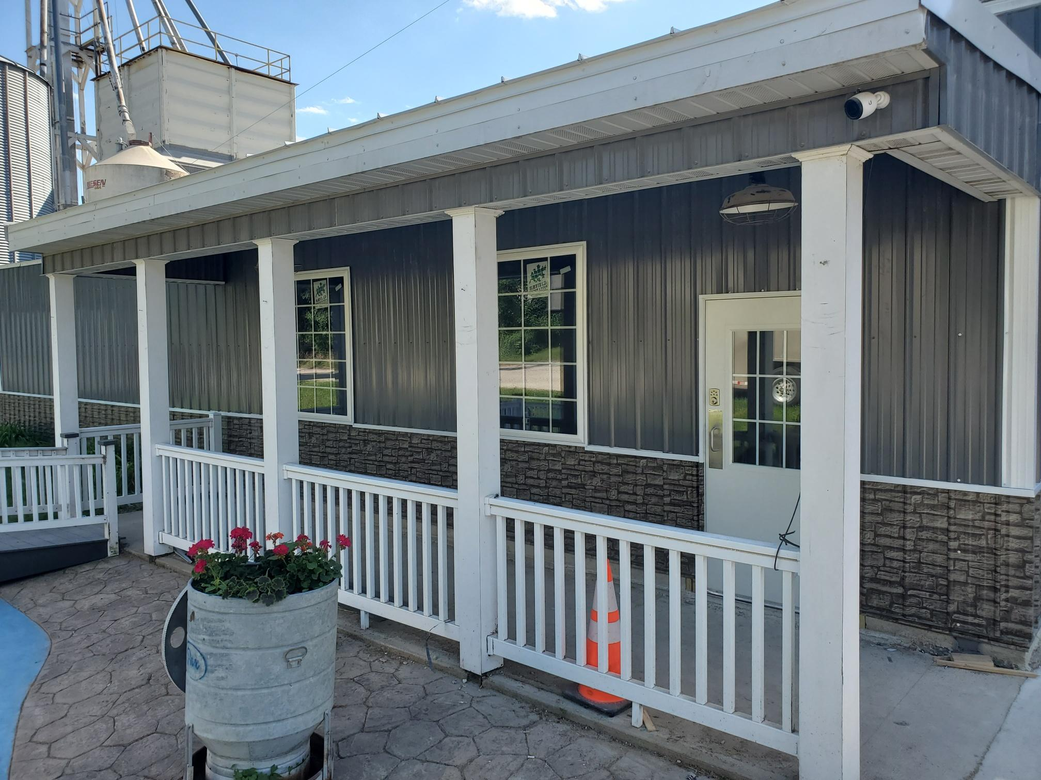  New walls, roof, doors, and windows will keep our office areas very tight, well insulated, more green, and save us money long term. We will also have a completely new layout to better serve our haulers, employees and customers!  We GREATLY appreciate your patience and cooperation while we progress very quickly with the office renovation project (and other projects including feed mill bins and new sack filling line). We have been able to focus a lot of time on these projects so we will be far more capable to serve everyone in the future. Another couple months to go, and we will have these projects complete and have time to serve you to the fullest extent!  You may see on the price list that a lot of products are marked as “Limited” or “OUT”. We are very short on supply with certain vendors due to lack of available byproduct supplies, but working hard to get more in soon. MANY ingredients (micro, macro, and retail) have increased in costs/prices recently as well. |  |  | New and improved sack filling line  Partially due to the office project with an entirely new layout, we have decided to also construct a new sack filling line this summer. This includes a heated/cooled room for employee comfort with a separate, brand new overhead bagging bin to feed the bagging scale. Our employees will greatly appreciate having the ability to fill feed sacks (a heavy manual job) in a heated and cooled environment very soon compared to our old setup which was in a cold warehouse location. Our previous sack filling line will become a dedicated tote bag fill line, which is a lot less work for our employees. This will also allow us to increase our overall bagging production, with a separate sack filling bin and a tote bag bin. This part of our overall renovation project will hopefully be completed by the end of August.  We just picked up our new overhead bagging bin from FCS Manufacturing in Gridley, Kansas! FCS Mfg. also built 5 of our overhead finished pellet bins in the recent years, and we really appreciate their precision and quality of work on these bins. Stay tuned with all our projects on our Facebook page!

Warehouse offerings!
CONTACT US!
300 Forest Street
Riceville, IA 50466
641-985-2494 Office
riversidefeeds@gmail.com
www.riversidefeeds.net
Current specials of available supplies. Please refer to enclosed Price List for all products. All items/products are FOB Riceville, IA. Please call to verify availability on all products. Customer pickup or delivery of products can be arranged anytime. |  |  |  |  |  | ORGANIC GRAIN PRICES:  *Upper Midwest References – NOT Riverside Feeds Offers  Corn: $12.00 / Bu  Soybeans: $37.00 + / Bu Feed, $39.00 + / Bu Food  Wheat: $12.00 / Bu  Barley: $12.00 / Bu  Oats: $10.00 / Bu  Soybean Meal: $1800 / Ton +
Smidley Livestock Waterer Equipment: single, double, and triple hog drinking bars available in used, refurbished condition.  Smidley used equipment special: Hog, Sheep, Goat portable head chute! A great condition oldie. Asking $950 OBO. Currently out of hog scales. |  |  | Organic Soybean Oil – Available in 1 ton liquid totes for $0.85 / #. Currently have 4 totes available.  Non-GMO Oat Mill Run Pellets – 50 pound sacks, totes, or bulk. Supply is readily available!  Organic Steamed Rolled Oats – Available in 2,000# totes or bulk. $1000 / ton.  Retail: Smidley, Crystal Creek, Fertrell, Redmond Agriculture, Redmond human & hunt products, Dr. Paul’s Lab, Dr. Sarah’s Essentials, Pyganic, Apple Cider Vinegar – For humans and animals!  Full Warehouse selection of vitamins, minerals, and ingredients! Ingredient prices have been going up, so stock up now to save money.
FUTURE EVENTS:
- Riverside Feeds Summerfest: We will be CLOSED on Wednesday, August 3rd, for employee team building and appreciation day. We will NOT have any function of our business operating that day, including all trucks, mills, and office. Please plan accordingly for all feed orders.
- Local town parades will be a major hit again this summer! Look for us in the coming weeks including Fourth of July parade in Osage on July 4th, Elma Old Roundhouse Trail Days on July 9th, Leroy Summerfest on July 17th, Stacyville Brat Days on July 30th, and Riceville Wapsi Days on August 6th!
- Keeping COVID-19 concerns in mind, please do NOT enter our premises if you are feeling ill or recently tested positive for COVID-19. Our office doors are OPEN to the public.
- We will have several construction projects take place again this year, so as always, please be cautious when picking up your feed orders over the next several months. We are currently in middle of very heavy office renovation work, and our temporary office is in a jobsite trailer in the East driveway.
- PLEASE NOTE - Office Hours: Monday – Thursday: 8 am – 5 pm. Friday: 8 am – 4 pm.
Seasonal Products:

Non-GMO Swine Feeds – Hog Starter/Grower pellets for $16 / 50# bag, and Hog Grower/Finisher pellets for $13 / 50# bag
Non-GMO Chick Starter Crumbles – STILL AVAILABLE!!! $20 / 50# bag
SunCoast Pine Shavings – Keep your chicks warm and dry! $9 / 25# bag 12 cubic foot

