. | The Feeder |  |  |  | May 2023

non-gmo soybean hulls available again
Recently, our Organic Soy Hull supplies have become extremely tight, which has been very popular with Mushroom growers to use for fertilizing and feeding mushroom production. In the feed business, (and especially when working with byproduct supply streams), our supplies come and go like feast or famine. As quickly as our organic soy hull supply vanished, Non-GMO soy hulls became more available again. We now can bring in a steady source of Non-GMO soy hulls, which can be blended with our famous Oat Mill Run Pellets to spike the protein and energy. This layered pellet blend is called “Soy-Oat Blend”, and we can blend any of the following percentages: 25/75, 50/50, or 75/25. The blended protein levels is easy math: Our Oat Pellets have 10% Crude Protein, and Soy Pellets have about 20% Crude Protein. A 50/50 blend would create about 15% protein feed. A blend that consists of 25% soy and 75% oat pellets would create about 12% protein. While our oat pellet supply has recently been tight from our supplier, making more Soy-Oat Blend orders does help our supply constraints. The straight up Rumapro Soy Hull Pellets can also be purchased if you are looking for a stronger protein and energy source for your ruminant animals (or Non-GMO soy hull pellets for Mushroom production). Call today for more information on any of these blends or pellets for your needs. |  | SAVE THE DATE!  Friday, August 4th, 2023  Riverside Feeds 10th Anniversary Open House – Riceville, IA  Due to supply constraints, we have been starting to get a bit tight on Non-GMO Oat Mill Run Pellet supply again. We are currently scheduled 2 solid weeks out on our feed truck and pellet orders due to the tight inbound raw supply, so please call us ahead of time if you are getting low. We do have a healthy supply to offer on several protein products including: Organic Opro 40 Soy Protein, Organic Okara Meal, Organic Flaxmeal, and Non-GMO Soy Hull Pellets.  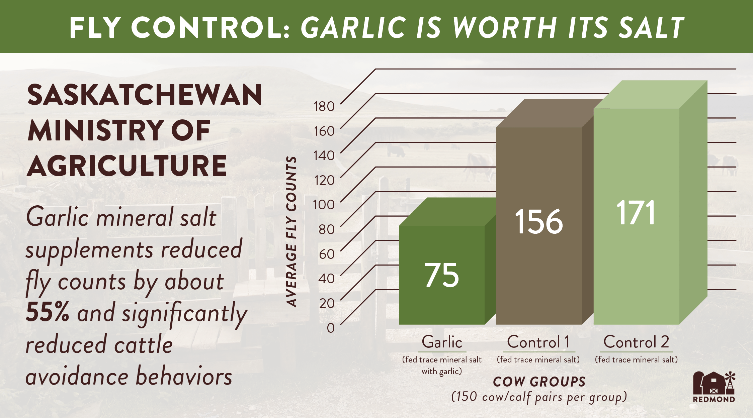  As we hope everyone has a safe and productive spring planting season, we want to remind you that our feed truck schedule is currently booked two solid weeks out on our logistics calendar. As farmers get busy in the field, we understand that checking bin levels can become a low or forgotten priority. We seriously would have major challenges to attempt to make magic happen, so please avoid any conflicts by spending an extra few minutes, check your feed supplies, and keep us in communication of when you need your next feed order.  Stop by today to get your Non-GMO Chick Starter and SunCoast Pine Shavings for those young fluffy friends! |  |  | summer fly control methods  NOW is the time to start implementing your summer fly control program on your livestock. If you start early enough and stay in front of the problem before it becomes a serious issue is the best approach. We have several products to help control flies organically. Dr. Sarah’s Essentials has Fly Spray made from essential oils, available in convenient spray bottles. We also stock Dr. Sarah’s Essentials Fly Spray Concentrate which is to be mixed with water to make larger quantities. Fertrell has a new ruminant mineral product out called Fly Aside. I have one bag of this on hand right now, and waiting to use this to see how effective it is. Redmond Agriculture offers our best selling bagged retail product, which is their NTM Fine Salt with Organic Garlic added. This garlic salt has proven to reduce fly population on multiple species by half. A reduced fly population greatly reduces health problems caused by flies, such as pinkeye.

Warehouse offerings!
CONTACT US!
300 Forest Street
Riceville, IA 50466
641-985-2494 Office
riversidefeeds@gmail.com
www.riversidefeeds.net
Current specials of available supplies. Please refer to enclosed Price List for all products. All items/products are FOB Riceville, IA. Please call to verify availability on all products. Customer pickup or delivery of products can be arranged anytime. |  |  |  |  |  | ORGANIC GRAIN PRICES:  *Upper Midwest References – NOT Riverside Feeds Offers  Corn: $10.00 / Bu  Soybeans: $26.00 + / Bu Feed, $29.00 + / Bu Food  Wheat: $9.00 / Bu  Barley: $7.00 / Bu  Oats: $5.00 / Bu  Soybean Meal: $1200 / Ton +
Smidley Livestock Waterer Equipment: single, double, and triple hog drinking bars and scales available in used, refurbished condition.  Seasonal Products:  Non-GMO Swine Feeds – Hog Starter/Grower pellets for $16 / 50# bag, and Hog Grower/Finisher pellets for $13 / 50# bag  Non-GMO Chick Starter Crumbles now available! $20 / 50# bag. Also have Non-GMO Layer Feed Pellets and Broiler Grower Pellets available at $17 / 50# bag. SunCoast Pine Shavings for $9 / 12 cubic foot bag. Stock up now for your flock!  Smidley used equipment special: Hog, Sheep, Goat portable head chute! A great condition oldie. Asking $950 OBO. Also have 2 hog scales available. |  |  | Organic Prewean 22 – This swine feed is made for young pigs to start on dry creep feed prior to weaning. $34 / 50#  Organic Opro 40 Soy Protein – Available either bulk or 2,000# totes. $950 / ton. Organic Okara Soy Protein – bulk or totes $1,000 / ton.  Non-GMO Rumapro Soy Hull Pellets - $250 / ton, available bulk or tote. Sacks can also be made available.  Organic Steamed Rolled Oats – Available in 2,000# totes or bulk. $1000 / ton.  EXPANDED Retail Shelf: Smidley, Crystal Creek, Fertrell, Redmond Agriculture, Redmond human (Real Salt & Re-Lyte) & hunt products, Dr. Paul’s Lab, Dr. Sarah’s Essentials, Pyganic, Apple Cider Vinegar – For humans and animals!
FUTURE EVENTS:
- We will be CLOSED on Monday, May 29th, in observance of Memorial Day. Please plan feed order accordingly.
- Local summer town parades will be coming soon – Look for our 10 Year Anniversary parade float in nearby town parades! Our first parade will be Alta Vista Days in Alta Vista, IA, on Saturday, June 3rd, at 11:30 AM.
- Riverside Feeds 10 Year Open House – Friday, August 4th, 2023, 1 pm – 6 pm, in Riceville, IA. Will include Food Trucks, Mill Tours, LIVE MUSIC, Beverages/Ice Cream, & Giveaways! Save the Date!!!
- Keeping COVID-19 concerns in mind, please do NOT enter our premises if you are feeling ill or recently tested positive for COVID-19 or Influenza. Our office doors are OPEN to the public.
- PLEASE NOTE - Office Hours: Monday – Thursday: 8 am – 5 pm. Friday: 8 am – 4 pm.

