. | The Feeder |  |  |  | May 2022

office renovation project underway
Construction season is fully underway here at Riverside Feeds! Two weeks ago we poured roughly 75 yards of concrete to allow us to start two different projects – Office renovation, and inbound raw ingredient bins! We will have a crane on site building two 18’ diameter hopper bottom bins on the Southeast side of our mill sometime in mid May. After these bins are built, we will increase our raw grain screening storage by about 250 tons!  We are currently in the beginning phase of demolition of our old office on the East side of the mill (facing Forest Street). We are moving the last few items out of our office into a temporary portable office unit which will sit on the concrete driveway immediately North of our office location. This office unit will house our primary operations and front desk services, plus our retail products. All truck drivers and customers/visitors MUST report to this office unit until our main office is fully renovated and we are moved back in, which is expected to take place in August.  With this office renovation, we will demolish and rebuild from the ground up the entire office area. This will include new concrete floors, new interior and exterior walls, new roof, new HVAC system, new windows & doors, and all new electrical and plumbing for our current needs. |  | The new layout will be entirely different than our previous layout, and will include brand new retail shelf area, office area for 4 full time positions, larger storage room for files and supplies, brand new rest room with shower, and brand new break room with a full kitchen for our hard working staff. With this project, we will continue construction efforts in August with a brand new sack filling line in a separate heated/cooled room as well. I can promise that you will be very impressed when this will all be completed later this year!  Please keep in mind during all of this construction to be cautious and curteous of our job site areas. Starting on May 2nd, please consider that our primary office as CLOSED TO PUBLIC, as we will be operating out of the temporary office unit in the East driveway. We will have signs stating this. Please do NOT randomly walk around our office renovation project site, as it could be dangerous or delicate. We all can work together to move forward and complete this project properly and in a timely manner.  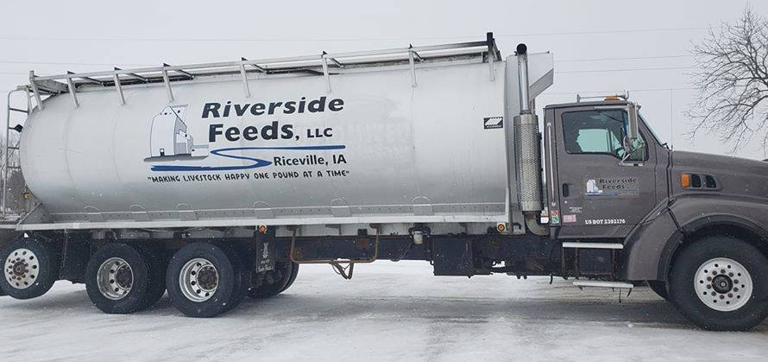  You may see on the price list that a lot of products are marked as “Limited” or “OUT”. We are very short on supply with certain vendors due to lack of available byproduct supplies, but working hard to get more in soon. |  |  | riverside feeds bulk feed truck  Many local/regional customers in the Tri-State area (IA, MN, WI) may receive bulk feed deliveries via our own Riverside Feeds feed truck. While it is a great advantage to have this large feed truck available to serve our customers, please keep in mind that this is a very expensive rig to maintain and operate. However, we take great pride with having this truck available to serve you!  Also please keep in mind that our single feed delivery truck runs a very busy schedule. Generally, this feed truck is booked a full week out at a time, so if you call to place an order, please remember that you may be on a list following several other customers who may already be scheduled. If you order a load of pellets to be split with your neighbors, we need all delivery locations confirmed with our office staff. We MUST have “Split/Multi” feed truck orders confirmed at a minimum of 24 hours prior to your expected shipment date, otherwise your order will automatically be canceled.

Warehouse offerings!
CONTACT US!
300 Forest Street
Riceville, IA 50466
641-985-2494 Office
riversidefeeds@gmail.com
www.riversidefeeds.net
Current specials of available supplies. Please refer to enclosed Price List for all products. All items/products are FOB Riceville, IA. Please call to verify availability on all products. Customer pickup or delivery of products can be arranged anytime. |  |  |  |  |  | ORGANIC GRAIN PRICES:  *Upper Midwest References – NOT Riverside Feeds Offers  Corn: $12.00 / Bu  Soybeans: $35.00 + / Bu Feed, $38.00 + / Bu Food  Wheat: $12.00 / Bu  Barley: $9.00 / Bu  Oats: $8.50 / Bu  Soybean Meal: $1600 / Ton +
Smidley Livestock Waterer Equipment: single, double, and triple hog drinking bars available in used, refurbished condition.  Smidley used equipment special: Hog, Sheep, Goat portable head chute! A great condition oldie. Asking $950 OBO. Currently out of hog scales. |  |  | Organic Soybean Oil – Available in 1 ton liquid totes for $0.85 / #. Currently have 4 totes available.  Non-GMO Oat Mill Run Pellets – 50 pound sacks, totes, or bulk. Supply is readily available!  Organic Steamed Rolled Oats – Available in 2,000# totes or bulk. $1000 / ton.  Retail: Smidley, Crystal Creek, Fertrell, Redmond Agriculture, Redmond human & hunt products, Dr. Paul’s Lab, Dr. Sarah’s Essentials, Pyganic, Apple Cider Vinegar – For humans and animals!  Full Warehouse selection of vitamins, minerals, and ingredients! Ingredient prices have been going up, so stock up now to save money.
FUTURE EVENTS:
- Memorial Day: We will be CLOSED on Monday, May 30th, for Memorial Day. Please plan accordingly for all feed orders.
- Local town parades will be a major hit again this summer! Look for our feed truck in the coming months, including Alta Vista Day Parade on Saturday, June 4th at 11:30 AM in Alta Vista, IA!
- Keeping COVID-19 concerns in mind, please do NOT enter our premises if you are feeling ill or recently tested positive for COVID-19. Our office doors are OPEN to the public.
- We will have several construction projects take place again this year, so as always, please be cautious when picking up your feed orders over the next several months. We will be constructing more bins for inbound product storage and will be undergoing a major office renovation project this summer.
- PLEASE NOTE - Office Hours: Monday – Thursday: 8 am – 5 pm. Friday: 8 am – 4 pm.
Seasonal Products:

Wildlife Feed Pellets – Fresh made, Now Available! $10 / 50# bag
Redmond Trophy Rock – Wildlife mineral rock. $15 / 20# rock
Non-GMO Chick Starter Crumbles – NOW AVAILABLE!!! $20 / 50# bag
SunCoast Pine Shavings – Keep your chicks warm and dry! $9 / 25# bag 12 cubic foot

