 | The Feeder |  |  |  | May 2021

will 2021 be a dry year? plan ahead now
I along with every farmer I know in Iowa have never seen such a dry April. Locally, we have only received 3/10ths of an inch of rain throughout the entire month! Not only is that unbelievably dry, but the temperatures have been very cold as well. These weather changes are leading us into an exceedingly difficult year to produce feed on farm, starting with pasture and hay production challenges. Proper planning prevents crises, and now is the time to start planning for feed shortages. Keep in mind that byproduct ingredients can help alleviate high costs of buying grain and hay to feed your livestock. While we are still very short on proteins, we do have a healthy and stable supply of Non-GMO Oat Mill Run Pellets which is a great fiber source. Organic supplies are limited, but grain screening supplies have been steady for our current and active accounts. If you would like to discuss your projected feed needs with me, please feel free to reach out anytime.  Also remember that a balanced diet for any species requires a proper mineral program. When you turn your livestock out to pasture this spring, keep us in mind when you want to build your mineral program as we stock many Redmond and Fertrell products, including mineral blocks. We also stock Acadian Kelp and Dr. Paul’s Aloe Pellets. |  | 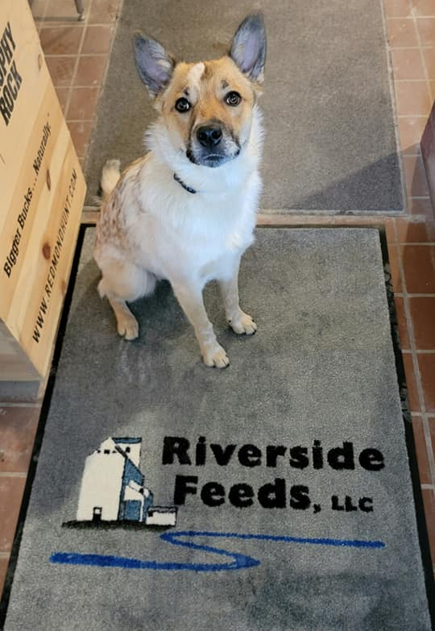  Customer Service Dog  Meet Chester, our newly trained in Customer Service Leader!  Enclosed in this month’s newsletter is a copy of the spring letter from Dr. Paul’s Lab! Please note a few product changes that will take place when we order more supply from them in the coming weeks. Also notice their recommendations on a proper trace mineral program when going out to pasture, and different worming options that we stock at Riverside Feeds.  Spring is a great time to use different wormers to cleanse internal parasites on all species of animals. Give us a call today to provide you with many options, including Dr. Paul’s Lab newest product – Clean Start Pellets! |  | 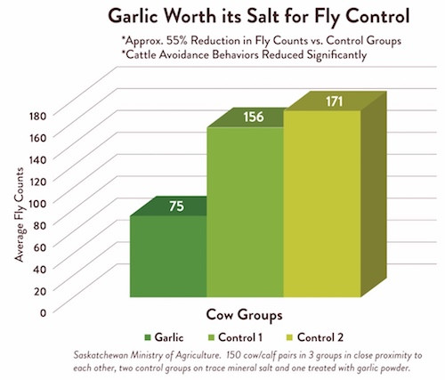 | Redmond trace mineral 10 fine salt with garlic:  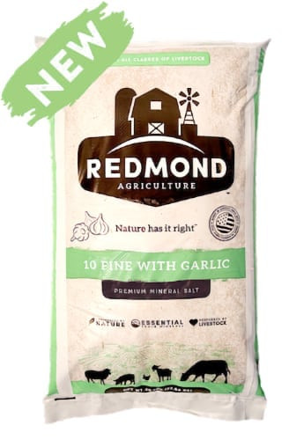  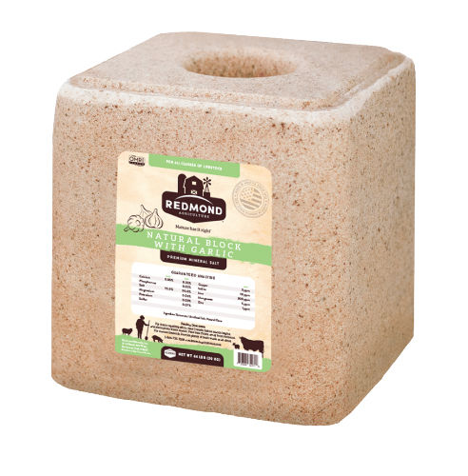  Over a year ago, Redmond Agriculture produced a new product derived from their famous trace mineral salt. They discovered that when adding a small portion of organic garlic powder with their salt, the garlic acts as a fly control on cattle. Feeding their TM 10 Fine Salt with Garlic, the fly population studies found 50% less flies compared to the control group! Now is the time to start feeding this product to your cows to manage summer fly problems. We carry both loose salt in 50# bags and the 44# blocks for your convenience.

Warehouse offerings!
CONTACT US!
300 Forest Street
Riceville, IA 50466
641-985-2494 Office
riversidefeeds@gmail.com
www.riversidefeeds.net
Current specials of available supplies. Please refer to enclosed Price List for all products. All items/products are FOB Riceville, IA. Please call to verify availability on all products. Customer pickup or delivery of products can be arranged anytime. |  |  |  |  |  | ORGANIC GRAIN PRICES:  *Upper Midwest References  Corn: $8.25 / Bu  Soybeans: $23.50 / Bu Feed, $24.50 / Bu Food  Wheat: $8.00 / Bu  Barley: $7.00 / Bu  Oats: $5.50 / Bu  Soybean Meal: $1100 / Ton
Smidley Livestock Equipment: single, double, and triple hog drinking bars & hog scale available in used, refurbished condition.  Seasonal Products:  SunCoast Pine Shavings – Keep your critters well bedded and warm!  Non-GMO Chick Starter Crumbles – NOW IN STOCK! $18 / 50# bag!  Redmond’s Trophy Rock – mineral supplement for wildlife – will promote antler growth on deer. Available for $15 / 20# rock.  Wildlife Feed – OUT OF STOCK!  Organic Oat Mill Run Pellets – can be offered in sacks or totes, but currently available in bulk. $185 / ton bulk. |  |  | Organic Steamed Rolled Oats – either 50 pound sacks, or 1600 pound totes, $900 / ton.  Non-GMO Oat Mill Run Pellets – 50 pound sacks, totes, or bulk. Stock up now before you run short on feed or hay products!  Non-GMO Pig Starter/Grower, and Non-GMO Hog Grower/Finisher in 50 pound sacks in stock.  Retail: Smidley, Crystal Creek, Fertrell, Redmond, Dr. Paul’s, Dr. Sarah’s, Pyganic, Apple Cider Vinegar – For humans and animals!  Full Warehouse selection of vitamins, minerals, and ingredients! Ingredient prices have been going up, so stock up now to save money.
FUTURE EVENTS:
- COVID-19 has started to reduce in Iowa earlier this spring, and with outdoor events starting to get planned, we are extremely excited to prepare for local town parades and county fairs! When we feel that the timing is right and potential exposure is reduced even more, we will finally look into hosting a production meeting in the future, discussing some of our products that we sell. We are also excited to get back on the road and travel around the country again soon, learning more about our products!
- There are some excellent recordings of workshop presenters from the MOSES Organic Farming Conference, including Dr. Paul Dettloff! If you would like to review these workshops, check out www.mosesorganic.org, Growing Stronger Conference.
- Keeping COVID-19 concerns in mind, please do NOT enter our premises if you are feeling ill or recently tested positive for COVID-19.

