. | The Feeder |  |  |  | April 2024

management/core team retreat 2024
On Saturday, March 2nd, our Management and Core Teams came together for a retreat in Osage, IA, to discuss some long term planning and goals, and how to work together as a team. This included James (myself), Paige, Douglas, Amanda, Dan, and Andy, which is a great representation across the entire business. We broke into small groups throughout the day for some very indepth discussions, and ended up spending most of the day discussing how to improve our team and to drive the rest of our production team towards success. We brought our discussions and ideas back to the rest of the group as a way to be as transparent to all employees as possible. It was decided that as this business continues to grow, we need to start having these retreats not just once, but twice a year so we can have more time to focus on two critical topics: Our Team, and Our Business. While I may personally own this business, it is important to know that our dedicated and talented team members are the ones who really take responsibility and pride into running this business together. We are looking forward to more retreats soon!  18 TON BULK FEED TRUCK SCHEDULE:  Currently 7 + business days out for deliveries – Staying busy with orders! |  | Price Reduction Notice! As we head out of the winter season and towards greener pastures, our supplier of the Non-GMO Oat Mill Run Pellets decided to reduce their price to help drive additional demand by $20 / ton. We are passing that price reduction through to our customers, so please take a careful note to the price list as Non-GMO Oat Mill Run Pellets are now a little cheaper than what they have been this past winter. Even though your animals might be moving out to pasture soon, these pellets can still offer a great supplement for your pasture. We also have a steady supply of Non-GMO Soy Hulls (Rumapro) at this time, and can fill orders instantly. We source in only high protein soy hulls (18% plus crude protein), which makes great alternative protein sources for cattle (dairy or beef). We also mix this product 50/50 with the Oat Mill Run Byproduct, and make Non-GMO Soy-Oat Pellets which has 15% protein. The Soy-Oat Pellets have been working very well for cattle and horses – depending on how much protein you are needing. Call today to discuss your feed pellet needs!  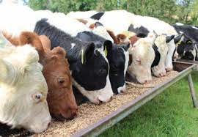 |  |  | Spring poultry products  It is that time of the year again – newborn chicks are available in farm supply stores or by mail order from hatcheries! Stop by today to stock up on all your feed, herd health, and bedding supplies for those young chicks as well as your mature flocks! Our Non-GMO, Non-Medicated chick starter crumbles is currently available, and we will continue to stock this seasonal product through August. Our Non-GMO, Non-Medicated Broiler Grower and Layer Feed pellets are also stocked, and we just received a fresh truck load of SunCoast Pine Shavings – 12 cubic foot bags, OMRI Approved for Organic Use! Dr. Paul’s Lab has multiple poultry products to help boost your flock health and immunity, including Poultry X for parasite control, Poultry Plus for scours, and Clean Start Liquid for the best take off for those chicks!  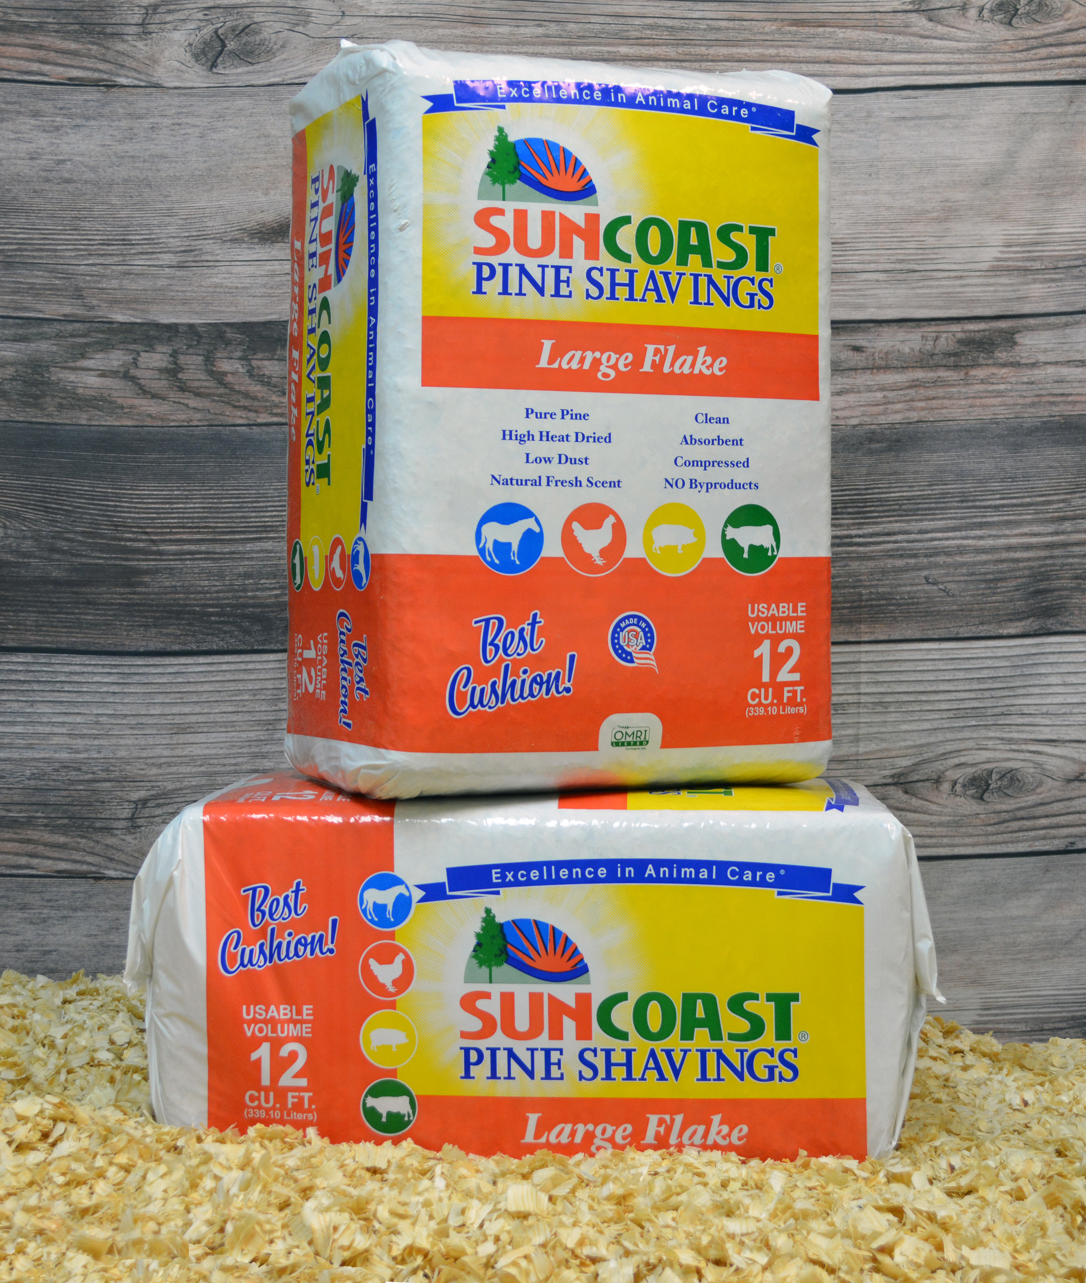

Warehouse offerings!
CONTACT US!
300 Forest Street
Riceville, IA 50466
641-985-2494 Office
riversidefeeds@gmail.com
www.riversidefeeds.net
Current specials of available supplies. Please refer to enclosed Price List for all products. All items/products are FOB Riceville, IA. Please call to verify availability on all products. Customer pickup or delivery of products can be arranged anytime. |  |  |  |  |  | ORGANIC GRAIN PRICES:  *Upper Midwest References – NOT Riverside Feeds Offers  Corn: $7.75 / Bu  Soybeans: $20.00 + / Bu Feed, $24.00 + / Bu Food  Wheat: $8.00 / Bu  Barley: $6.00 / Bu  Oats: $4.50 / Bu  Soybean Meal: $925 / Ton +
Smidley Livestock Waterer Equipment: single, double, and triple hog drinking bars and scales available in used, refurbished condition.  Seasonal Products:  Redmond SR35, SR50, & SR65 blends for your soil amendment needs! Can order in tote quantities - $425 / 2000# Tote.  Non-GMO Chick Starter – NOW AVAILABLE! $22 / 50#.  Non-GMO Hog Starter-Grower and Grower-Finisher: $17 & $14/50# bag  SunCoast Pine Shavings for $9 / 12 cubic foot bag.  Smidley used equipment special: Hog, Sheep, Goat portable head chute! A great condition oldie. Asking $950 OBO. New digital hog scale available. |  |  | Dr. Paul’s Lab Clean Start Pellets – All natural dewormer/intestinal cleanser for ALL species of livestock! $85 / 25#  Non-GMO Soy Hull Pellets (Rumapro) – 18% minimum protein. Great alternative cattle feed! $250 / ton bulk. Ask about Soy-Oat Pellets!  Organic Apple Cider Vinegar – 55 gal drums $525, or 4 gal pail $45. Non-GMO Apple Cider Vinegar avail too.  Non-GMO Whole Oats (Heavy Weight/Race Horse Oats) - $450 / ton in either 40# or 50# sacks.  EXPANDED Retail Shelf: Smidley, Crystal Creek, Fertrell, Redmond Agriculture, Redmond human (Real Salt & Re-Lyte) & hunt products, Dr. Paul’s Lab, Dr. Sarah’s Essentials, Pyganic, Apple Cider Vinegar – For humans and animals!
FUTURE EVENTS:

- We will be CLOSED on Good Friday for the Easter Holiday, which is Friday, March 29th. We will be open on Easter Monday, April 1, for regular hours and business. Please plan your feed orders accordingly. Happy Easter!

- Stay tuned with next month’s newsletter – Will be featuring a newer 21 ton bulk feed truck purchase that is currently underway!

- No other events planned at this time. Have a safe spring farming season!

- PLEASE NOTE - Office Hours: Monday – Thursday: 8 am – 5 pm. Friday: 8 am – 4 pm.

