. | The Feeder |  |  |  | March 2022

redmond agriculture meeting march 8
We are very excited to host Tim Williams with Redmond Agriculture this coming Tuesday, March 8th, at the Riceville Community Center from 10 am – 3 pm to discuss Redmond’s products and benefits from using those products for all species of livestock, humans, and soil admendments. Redmond has many products to offer with very unique benefits since their salt includes over 65 trace minerals that are very healthy for all living organisms. They have also very recently developed a Direct Fed Microbial product to enhance immunity and stomach health during the first month for calves. First Month DFM can be mixed right into milk replacer or tank milk for new born calves. There are MANY great products and benefits from Redmond, so please consider attending this meeting to learn more. We will begin with coffee hour at 9 am prior to the meeting, and lunch will be provided by Hall Robert’s Son, Inc.  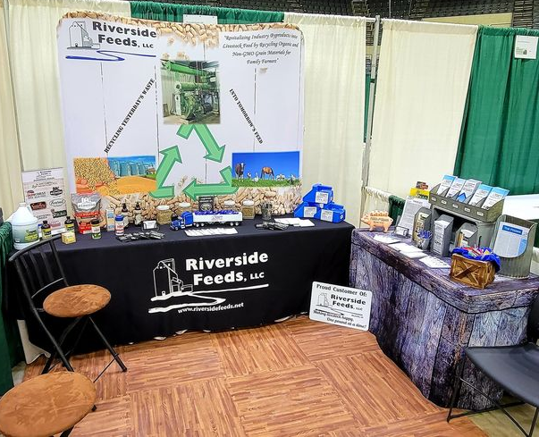  MOSES Organic Farming Conference – LaCrosse, WI, February 24th – 26th. |  | We attended the MOSES Organic Farming Conference in LaCrosse, WI, just last week. It was great to get back together with farmers and other businesses in the industry, after having virtual only conferences last year.  With temperature swings in mind, it is very important to consider extreme temperature change stress points on your livestock (all species). To help build immune systems and avoid pneumonia, it is critical to provide fresh, clean bedding packs and to also feed Dr. Paul’s Aloe Pellets. These aloe pellets are safe for all species of livestock and can make a big difference if properly fed. I recommend feeding the proper amount per body weight for a minimum of 10 days at a time. This is highly recommended for stressful weather changes coming soon.  Spring is also just around the corner! The next couple of months is a great time to consider feeding a dewormer to your livestock to cleanse their intestinal systems. We stock multiple options for all species, including poultry, swine, ruminants, and equine – all from Dr. Paul’s Lab, which is allowed for organic use. Enclosed, you’ll see Dr. Paul’s Lab quarterly newsletter, and they have a great new product to offer for your dogs to cleanse any worms in them. Call today to order Clean Dog! |  |  | Non-GMO Poultry Feed Season is near!  Who’s ready for warmer temps, melting snow, green grass, and the sound of newly hatched fluffy chicks chirping loudly in the barn or coop? After the extreme cold temps we experienced last couple of months, I know I surely am! In a couple of weeks, (around mid-March), we will be gearing up and producing fresh supplies of our Non-GMO Poultry Feeds, including our Chick Starter Crumbles! Please call before coming to assure that we have our Chick Starter Crumbles made and available for you. Our Layer Pellets and Broiler Grower Pellets are always stocked and readily available.  Non-GMO Poultry Layer Pellets - $17 / 50# bag  Non-GMO Broiler Grower Pellets - $17 / 50# bag  Non-GMO Chick Starter Crumbles - $20 / 50# bag  Dr. Paul’s Lab Poultry X – intestinal cleansing & health – $26 / 60 ounce, or $66.50 / 5 quart  Dr. Paul’s Lab Poultry Plus – scours & health - $20 / 64 ounce  SunCoast Pine Shavings - $8 / 12 cubic foot bag

Warehouse offerings!
CONTACT US!
300 Forest Street
Riceville, IA 50466
641-985-2494 Office
riversidefeeds@gmail.com
www.riversidefeeds.net
Current specials of available supplies. Please refer to enclosed Price List for all products. All items/products are FOB Riceville, IA. Please call to verify availability on all products. Customer pickup or delivery of products can be arranged anytime. |  |  |  |  |  | ORGANIC GRAIN PRICES:  *Upper Midwest References  Corn: $10.50 / Bu  Soybeans: $32.00 + / Bu Feed, $34.00 + / Bu Food  Wheat: $17.00 / Bu  Barley: $9.00 / Bu  Oats: $8.50 / Bu  Soybean Meal: $1550 / Ton
Smidley Livestock Equipment: single, double, and triple hog drinking bars & hog scales available in used, refurbished condition.  Non-GMO Soy-Oat Pellets - *Please call in advance as this is available only in limited supplies at this time until we can source more soy hulls. |  |  | Non-GMO Soy Pro 50 – Now back in stock! Excellent high quality protein source. Stock up while it’s available!  Non-GMO Oat Mill Run Pellets – 50 pound sacks, totes, or bulk. Supply is readily available!  Non-GMO Pig Starter/Grower, and Non-GMO Hog Grower/Finisher in 50 pound sacks in stock.  Retail: Smidley, Crystal Creek, Fertrell, Redmond Agriculture, Redmond human & hunt products, Dr. Paul’s Lab, Dr. Sarah’s Essentials, Pyganic, Apple Cider Vinegar – For humans and animals!  Full Warehouse selection of vitamins, minerals, and ingredients! Ingredient prices have been going up, so stock up now to save money.
FUTURE EVENTS:
- Redmond Agriculture Workshop – Tuesday, March 8th, Riceville Community Center, Riceville, IA. 10 am – 3 pm, with coffee hour starting at 9 am. Learn more about Redmond’s products from Tim Williams for livestock, human, and soil benefits. Hosted by Riverside Feeds, including lunch. RSVP not required, but greatly appreciated. Please call our office for more information.
- Keeping COVID-19 concerns in mind, please do NOT enter our premises if you are feeling ill or recently tested positive for COVID-19. Our office doors are OPEN to the public.
- We will have several construction projects take place again this year, so as always, please be cautious when picking up your feed orders over the next several months. We will be constructing more bins for inbound product storage and will be undergoing a major office renovation project this summer.

- PLEASE NOTE - Office Hours: Monday – Thursday: 8 am – 5 pm. Friday: 8 am – 4 pm.
Seasonal Products:

Wildlife Feed Pellets – Fresh made, Now Available! $10 / 50# bag
Redmond Trophy Rock – Wildlife mineral rock. $15 / 20# rock
Non-GMO Chick Starter Crumbles – Will be available by mid-March. $20 / 50# bag
SunCoast Pine Shavings – Keep your chicks warm and dry! $8 / 25# bag 12 cubic foot

