. | The Feeder |  |  |  | October 2023

are you ready for the cold season yet?
September 10th – 16th was National Truck Driver Appreciation week! Just in the United States, there are over 3.5 million professional men and women who not only deliver our goods safely, securely, and on time, but they also keep our highways safe. Our highways are already getting more congested as we head into fall harvest and see more farm equipment on these road ways. Hopefully, all farmers and drivers will have a successful and safe fall harvest season and avoid any potential accidents. We truly appreciate the dedicated and highly skilled drivers that we have on staff, which includes Dan, Andy, and Kyle. These drivers would not have any organized schedule and orders without a very important person that is behind one of the office desks everyday answering the phones and emails and routing our trucks. That person would be Douglas, whom many of you talk to when placing your bulk or bagged feed orders, and he assures timely delivery to our customers. Thank you to ALL of our drivers and logistical dispatchers in the USA! |  | Need plumbing or electrical parts for your Smidley hog, sheep/goat, or cattle water fountain before the real cold weather comes? Now is the time of the year to check to make sure that all these replacement parts are in full working order, and it is always smart to stock these parts on hand if you use Smidley fountains in case you need parts on a weekend or late-night repair. Our retail shelf is always well stocked with all these common Smidley parts:  - Rubber Flush Plug  - Short or Long Float  - Valve  - Thermostat  - Single drink heat element  - Two drink heat element  - Four drink heat element  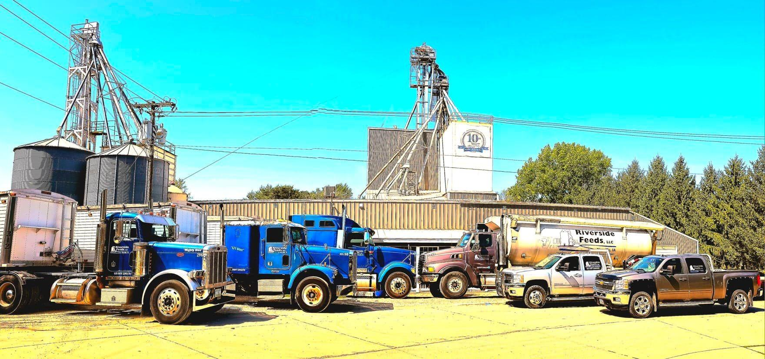  Dr. Paul’s Aloe Pellets are highly recommended to be offered during temperature changing stresses like spring and fall seasons. Aloe pellets are great to enhance immune systems and fend off colds and illnesses due to stress related times, including transport stress for all livestock. |  | 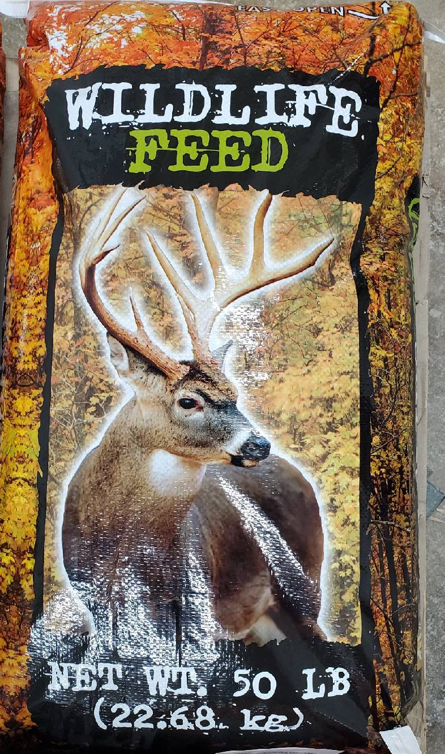  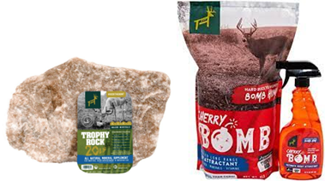 | Fall animal feeds  We have many seasonal feed products, especially for the colder temperatures that will soon be coming. We stock Redmond Hunt’s trophy rock, which is a mineral rock for all wildlife species, which really helps promote antler growth on deer. We also have Redmond’s apple or cherry bomb pellets and spray to entice wildlife habitats. Recently, we made our own fresh supply of Wildlife Feed Pellets up as well.  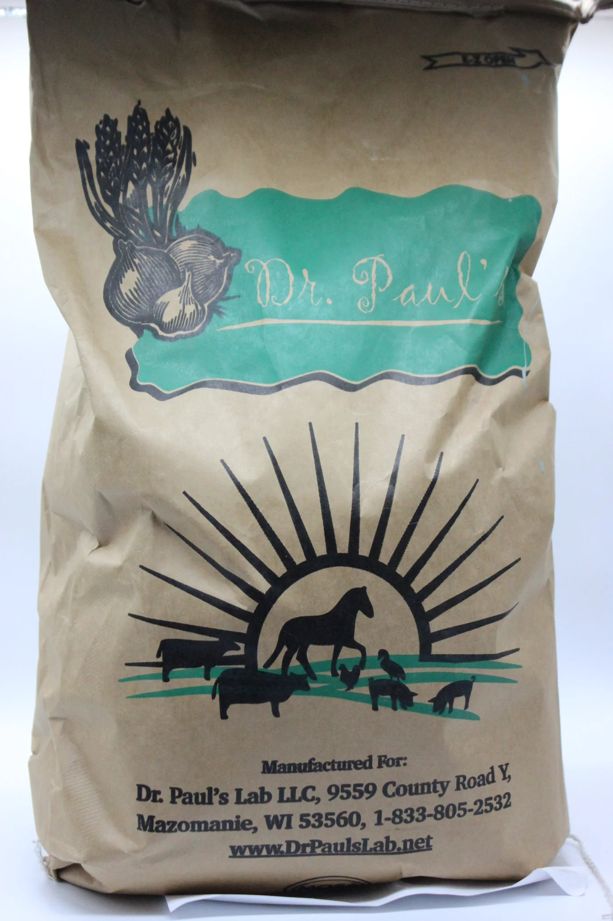  With the colder temperatures on the way, it is also important to promote gut health and strong immune systems for all species of livestock. Now is a great time to offer intestinal cleansing products including Dr. Paul’s Clean Start Pellets for any species or Poultry X, Swine X, or CGS Remedy to your herd.

Warehouse offerings!
CONTACT US!
300 Forest Street
Riceville, IA 50466
641-985-2494 Office
riversidefeeds@gmail.com
www.riversidefeeds.net
Current specials of available supplies. Please refer to enclosed Price List for all products. All items/products are FOB Riceville, IA. Please call to verify availability on all products. Customer pickup or delivery of products can be arranged anytime. |  |  |  |  |  | ORGANIC GRAIN PRICES:  *Upper Midwest References – NOT Riverside Feeds Offers  Corn: $8.50 / Bu  Soybeans: $20.00 + / Bu Feed, $26.00 + / Bu Food  Wheat: $8.00 / Bu  Barley: $6.00 / Bu  Oats: $4.50 / Bu  Soybean Meal: $950 / Ton +
Smidley Livestock Waterer Equipment: single, double, and triple hog drinking bars and scales available in used, refurbished condition.  Seasonal Products:  Non-GMO Wildlife Feed Pellets (grain and protein mix with molasses and cherry flavoring) - $10 / 50# bag.  Remond Hunt Trophy Rock – mineral rock for wildlife. $15 / 20#.  Non-GMO Chick Starter Crumbles still available! $22 / 50# bag.  SunCoast Pine Shavings for $9 / 12 cubic foot bag.  Smidley used equipment special: Hog, Sheep, Goat portable head chute! A great condition oldie. Asking $950 OBO. Also have 2 hog scales available. |  |  | Dr. Paul’s Lab Clean Start Pellets – All natural dewormer/intestinal cleanser for ALL species of livestock! $85 / 25#  Organic Opro 40 Soy Protein – Available either bulk or 2,000# totes. $950 / ton. Organic Soybean Meal - $950 / ton. Can blend these products.  Organic Apple Cider Vinegar – 55 gal drums $525, or 4 gal pail $45. Non-GMO Apple Cider Vinegar avail too.  Organic Steamed Rolled Oats – Available in 2,000# totes or bulk. $1000 / ton.  EXPANDED Retail Shelf: Smidley, Crystal Creek, Fertrell, Redmond Agriculture, Redmond human (Real Salt & Re-Lyte) & hunt products, Dr. Paul’s Lab, Dr. Sarah’s Essentials, Pyganic, Apple Cider Vinegar – For humans and animals!
FUTURE EVENTS:

- Conference season will soon be upon us! Look either in your mailbox or online for upcoming winter farming conference invites & registrations to learn more about sustainable agriculture! We may not be available to attend and exhibit at every conference during the winter season, but we do highly recommend several very good conferences, and are intending to participate in the following:
- Iowa Organic Conference, Iowa City, IA – November 26 & 27, 2023
- Minnesota Organic Conference, St. Cloud, MN – January 11 & 12, 2024
- Practical Farmer’s of Iowa Annual Meeting, Des Moines, IA – January 19 & 20, 2024
- OGRAIN Conference, Madison, WI – February 2 & 3, 2024
- Marbleseed Organic Farming Conference, LaCrosse, WI – February 22 – 24, 2024

- PLEASE NOTE - Office Hours: Monday – Thursday: 8 am – 5 pm. Friday: 8 am – 4 pm.

