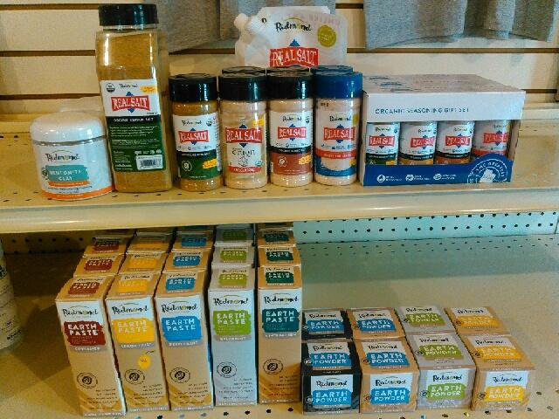

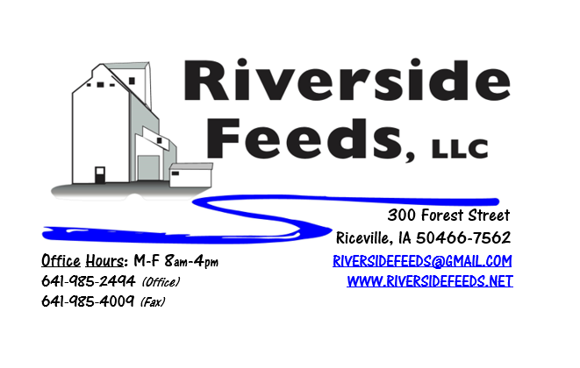
September 2019 Newsletter
Did you know that we now carry a wide variety of retail products, including healthy human options? I never imagined I would get into selling tooth paste of all products, but since Redmond Agriculture has a great display of products (pictured above), we now are fully stocked and offer Earth Paste and Earth Powder for your dental hygiene needs! We also carry Real Salt products, including seasonings for your food products! My FAVORITE is Redmond’s Real Salt Seasoning on my steaks or chops! We also now carry Redmond’s Goat Mineral, in 5# or 25# bags. Beside the goat mineral, we also fully stock Redmond’s TM salt (both bags and blocks), Conditioner Coarse, Beef Mineral, and SR 65. Check out our price list on all of Redmond’s products.
Mistral is a dry absorbing powder made from algae. This product can be used to absorb humid moisture off newborn animals, bedding packs, building atmosphere, and livestock trailers. Recently, we also found that the odor from Mistral helps reduce fly population. We used this powder in a calf pen and on the bottle calf and found almost no flies for multiple days! We always carry a couple bags of Mistral on hand.
REMINDER: Saturday Hours during Summer months are by APPOINTMENT ONLY!
Organic Grain Prices:
We are expecting for organic corn prices to steadily rise as we near this fall’s harvest. The threat of an early frost (sorry for even mentioning it!) may change the corn market drastically. Right now, organic corn is trading in the $9.50 - $10.00 range here in the Midwest, but I would expect this to continue to rise through the next few months.
Beans have fallen due to the low cost imported meal. Organic soybeans are trading between $18.50 - $20.00 a bushel here in the upper Midwest, and Wheat is around $8.50 - $9.75. Domestic organic Soybean Meal is trading around $775-$850 per ton. Barley is around $8.00 - $9.00. Oats are moving in the $4.50 - $6.50 per bushel.
Events Coming Up:
If there are field days or events that you would like to share with our customer base, please feel free to provide us the information and we will include it in next month’s newsletter!
- Welsh Family Organic Farm, Lansing, IA, will have a Corn Test Plot and Cover Cropping field day on Friday, September 13th, starting at 10:30 AM. Lunch will be provided, and this field day is sponsored by Organic Valley. Call Gary Welsh for more details at 563-535-7318
Products We Offer:
Need soy protein? We have multiple options available right now of Non-GMO Soy Pro 40, Soy Pro 50, and Soy Pro 55! We are willing to negotiate deals on full truck load quantities of these products. If you are running short on roasted beans in your rations this fall, Soy Pro 40 makes a great replacement!
We also have liquid totes of Non-GMO soybean meal and soy oil blend (very wet saturated blend) available at a great price! This is a byproduct from an extruding plant, and we are looking for a home for this. This could be used as a fat source in multiple rations. We also have a couple totes of Non-GMO Soy Oil (no meal blend) available for sale too, and at a great price! This oil can be used as a fat source for horses. Call today for more information!
We do have a good supply of Organic Steamed Rolled Oats on hand – Either in 1600# totes, or 50# bags. Call today for your needs – This makes GREAT nursery pig feed.
We just made a fresh batch of Non-GMO Wildlife Feed pellets up today! This mix includes a mixture of soy screenings, corn, molasses, and a few other goodies that will attract multiple wildlife species. This is a fall seasonal special and is offered in 50# bags.
Poultry Feeds:
Remember that we do offer our Non-GMO Broiler Grower and Layer feeds at Riceville True Value store here in town! We also have a healthy supply of SunCoast Pine Shavings available for all your bedding needs.
Swine Feeds:
Give us a call for your Organic Prewean 22 feed needs! We also have Non-GMO Starter-Grower and Non-GMO Grower-Finisher pellets on hand in 50# bags! We also carry many swine feed ingredients including organic steamed rolled oats, organic buttermilk powder, organic alfalfa meal, and more! Aloe C can be used as a treatment in water to help build a strong immune system in swine.
Bovine Feeds:
We do have some Organic Calf Starter Pellets available. We also now have an organic milk replacer stocked on hand and ready for your use when needed! Redmond has a Beef Mineral mix that we have on hand.
Equine Feeds:
Multiple products available including our very own complete Horse Mix Pellets, Fertrell Horse Power Mineral, Equine Kelp, and Oat Screening Pellets. A lot of Dr. Paul’s and Dr. Sarah’s Essentials products are also great to use for all equine. Oat Screening Pellets have been working great for extending hay and whole oat needs on horses. We do have Non-GMO Soy Oil available either in 275 gallon totes or 5 gallon pails. We also have soy meal/oil blended product available.
Dr. Paul’s Products:
Wellness Tonic can be used to help weak cows, ketosis, and a post-surgery energy boost. It is made from Aloe, Vitamin C, Dandelion, Plantain, Rosehips, and Apple Cider Vinegar, and is available in 1-gallon jugs.
Used Smidley Livestock Equipment Available:
We do have multiple options available for stainless steel hog bars. We can order any brand new Smidley livestock equipment. Smidley makes mineral feeders, steer stuffers, multiple sizes hog feeders (both stainless steel and wood), hog scales, hog huts, and livestock water fountains. We stock a full selection of Smidley livestock water fountain parts! We can also order in any Smidley Feeder parts.
For Sale: Clipper 67D Cleaner with many screens for sale in excellent condition and ready to run. Asking $9,500 OBO. Will clean many different grains and is easy to run. Schlagel Grain Distributor. 8”, double 24 hole swing. $4,500 OBO.

THANK YOU FOR YOUR BUSINESS!!!
“Revitalizing Industry Byproducts into Livestock Feed by
Recycling Organic and Non-GMO Grain Materials for Family Farmers”

