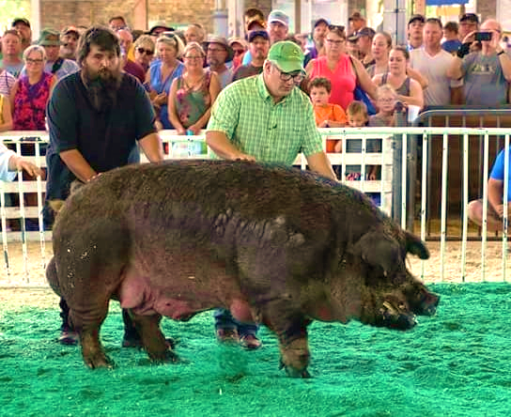
Our part time feed mill operator, Bob Owen, won Reserve Champion Big Boar at the Iowa State Fair this last month! “Yo-yo” weighed in at 1161 pounds, only TWO pounds less than the Champion Big Boar!

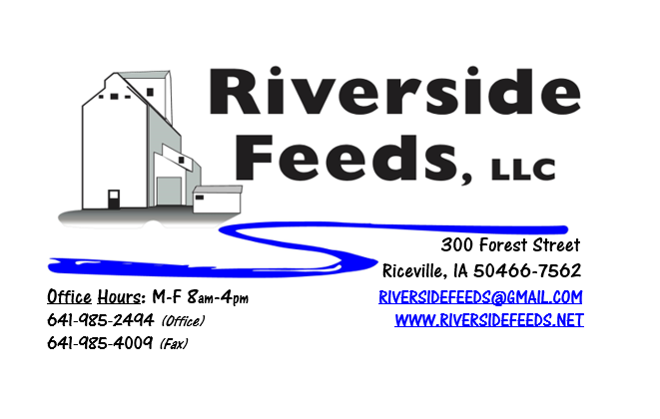
September 2018 Newsletter
What an interesting month it has been! Here in the tri-state area, we have been extremely wet with very heavy rains lately. You may have seen in the news or are located in the southwest Wisconsin area which was devastated by severe flooding this past week, and our thoughts are with our customers and vendors located there. We hope they can build back and stay strong, but we do fully understand that it’ll take a lot of time to heal after such damages.
What’s Happening:
As business continues to grow each month, we have been stressed to the limit with staffing, and made the decision to hire more help! We have hired three new full time people in the last two months. Dan has been busy being a “floater” feed mill operator and back up truck driver, while Spenser has been working into the 2nd shift as a pellet mill operator. Our newest hire is Doug, who will be working at the front door in the office. Doug is a young, energetic individual who will be answering the phone calls, walk in customers, and in due time, will be organizing trucking logistics and managing our inventory. We are expecting that it’ll take several weeks for Doug to become fully trained and comfortable with the business and our customers. I encourage you to call our office number and introduce yourself to Doug so he can get to know you and understand some of our common feed orders.
Organic Grain Prices:
Organic grains always become a little short this time of the year, so traders are eager to find new crops available soon. Corn is now trading in the $10.00 - $11.00 range, which has certainly increased since this spring. Barley is holding steady around $8.50.
Beans are trading between $20.00 - $22.00 a bushel here in the upper Midwest (Feed – Food, respectively, and Wheat is around $8.50 - $9.00. Soybean Meal is up a little, and is trading around $850-$900 per ton. If you have any organic soybeans to sell, please contact myself or Linda Holthaus at Agra Trading immediately. Beans are becoming short, and additional supply now before new crop is in demand.
Events Coming Up:
If there are field days or events that you would like to share with our customer base, please feel free to provide us the information and we will include it in next month’s newsletter!
- Organic Vet Clinic, Viroqua, WI, September 19-21. This event is hosted by Organic Valley, but is open to anyone who may be interested in learning more about organic veterinarian practices. Amanda and I will be attending to learn more! Contact Organic Valley Farmer Hotline for more information.
Products We Offer:
We are long on organic soy protein (Opro 40), and Non-GMO soy protein (SoyPro 50). Call and check in with me if we can fill any of your needs! I can offer a great deal on the Opro 40 if we can move a full semi load. We are long on Non-GMO Oat Screenings pellets (Not organic) available for sale yet, and can ship that out in bags, totes, or bulk quantities. We can ship any quantity out the door, and usually carry at least a few ton on hand. We also carry organic and conventional Apple Cider Vinegar, either in 4 gallon pails or 55 gallon drums. As always, we have a full line of vitamins and minerals and many other ingredients. If you would like to see us carry a certain product on our retail shelf, please let us know and we will certainly consider adding more!
Poultry Feeds:
If anyone needs any chick starter for any late flocks, I do have a few bags left to use up. I’m willing to sell them at a discounted rate, so call soon! Non-GMO Broiler Grower, Non-GMO Poultry Layer, and Suncoast Pine Shavings (OMRI Approved) is on hand at all times. We also have Poultry Grit and Oyster Shells available for retail. Dr. Paul has Poultry Plus (scours) and Poultry X (wormer) for your poultry health needs!
Swine Feeds:
Call today to place your order on any swine feed products. Reminder – we have a minimal production run for our mill, but we could split a few orders up with other customers. Dr. Paul has PigAde (scours) and Swine X (wormer) for your swine health needs! By-O-Reg Plus is made up with a natural oregano essential oil (plus other organic ingredients), and is highly recommended for all stages of swine and poultry. We have started to use this in our Prewean 22 line, and our Non-GMO Poultry Feeds! Call for more information!
Bovine Feeds:
I have several bags of Organic Calf Starter 14% Pellets on hand yet. If anyone has some young calves needing a good starter pellet, please let me know and we can get you some bags to try! These pellets are very sturdy and sweet, and I can make this using Non-GMO ingredients as well. (Both organic and Non-GMO calf starter is listed on price sheet) Oat screenings can be a good grain extender and fiber filler for all bovine, and also equine. We are long on Non-GMO oat screenings – call today to place your order! Dr. Paul has MANY items for bovine uses, especially calf start (scours), CGS Remedy (wormer), S&G Pills (wormer for sheep, goats, and calves), and Detox (moldy/toxic feed) for your bovine health needs!
Horse Feeds:
Our new Horse Mix Pellets is on hand in 50# bags, and can be delivered or picked up anytime! Detox can be used on Bovine or Equine to assist the gut health if the animal has been exposed to moldy or toxic feed products. Horse rations can be very complicated, so please consult with me if you have any questions. We can make custom orders.
Dr. Paul’s Products:
This month’s sales special on Dr. Paul’s products is “Necessities”. Delice & Mange, both 32 and 64 ounce is on sale. Super Wound 22 ounce spray and 64 ounce refill is also on sale. Stock up now on both of these products as they will be 10% off through September. This is the last month of Dr. Paul’s sales for this summer.
Used Smidley Livestock Equipment Available:
We are looking for good, used Smidley hog scales and waterers. Current used water fountain supply is VERY limited. We can order any brand new Smidley livestock equipment. Smidley makes mineral feeders, steer stuffers, multiple sizes hog feeders (both stainless steel and wood), hog scales, hog huts, and livestock water fountains. We stock a full selection of Smidley livestock water fountain parts!

THANK YOU FOR YOUR BUSINESS!!!
“Revitalizing Industry Byproducts into Livestock Feed by
Recycling Organic and Non-GMO Grain Materials for Family Farmers”

