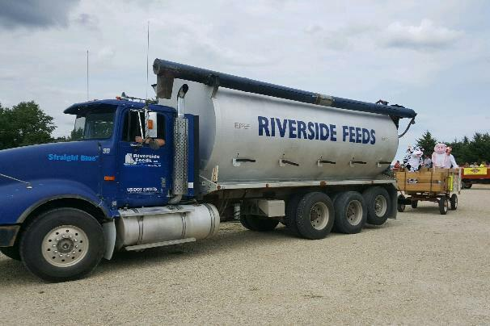
Wapsi Days Parade Float on August 5th. “Straight Blue” feed truck pulling a wagon load of livestock!

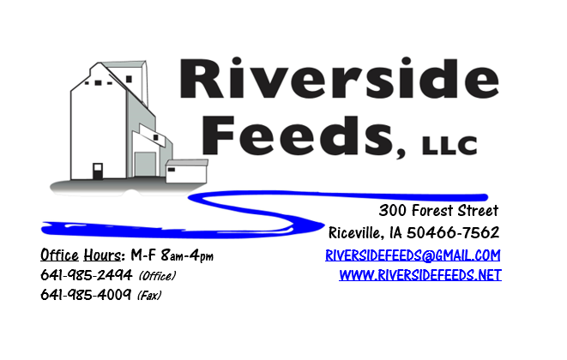
September 2017 Newsletter
Hi everyone! We hope that this summer has been treating you well. Crops are looking very good around here as we have had some very nice rains in July and August.
What’s Happening:
As we have been steadily increasing our tonnage each week through both the hammer mill and pellet mill, we have decided to start hiring for second shift effective immediately. We have been working very long days and paying out a lot of overtime, so this decision was not too complicated to reach to. This will take some time to get together as we will need multiple people for second shift, and they will need to train on first shift for a while. We ask you to please be patient as we make this transition, but in due time, we will be running 7 am to 11 pm, five days a week. PLEASE place your feed orders as early as you can. Right now, we usually run with a FULL schedule up to four days out, so when an emergency order comes in, we are all working overtime to complete it. We have no problem with assuring that everyone gets their feed on time and provide superior customer service, but it would help us maintain an efficient schedule if we can plan ahead.
Organic Grain Prices:
Organic Grain prices have been holding steady, despite some recent federal investigations on fraudulent brokers with imported grains. PLEASE call me if you have any concerns at all about imported grains and I’ll discuss this risky situation with you. As for our products, we have sent an affidavit out to all of our suppliers requesting information about where their products are imported from, and to help assure that our products are not origin from current at-risk countries.
Beans are trading between $18.00 - $20.00 a bushel here in the upper Midwest (Feed – Food, respectively), and corn is trading between $8 - $9 a bushel. Barley is around $8.00 - $8.50, and Wheat is around $8.50 - $9.00. Soybean Meal is trading between $800 - $850 per ton. I have heard reports of a lot of old crop grain in bins (both organic and conventional), and this may impact harvest some.
Services We Offer:
Please contact us if you or anyone who you know may be looking for custom pelleting options. Our services now include: Warehousing (including loading dock), Hammer mill, Mixer, Pellet Mill, Crumbler, and load out in either bulk, tote bags, or feed sacks. We also have a fleet of trucks and trailers. After we finish up some projects around here, we will also have grain cleaning capabilities with a Clipper fanning mill, but that will not be until sometime in 2018.
Events Coming Up:
If there are field days or events that you would like to share with our customer base, please feel free to provide us the information and we will include it in next month’s newsletter!
Products We Offer:
We are currently long on Organic “Opro 40” protein, and now offer that in a crumblized form to keep the texture consistent. Pricing on that is $825 per ton, and available in either tote bags or bulk. We have an endless supply of either organic or Non-GMO Ground Oat Screenings (pelleted). Using these oat screening pellets in your cattle rations (dairy or beef) can help replace corn! We are ramping up our production of both organic and non-gmo soy hulls, so if you need some alternative soy pellets as a feed ingredient, please give me a call today. We do carry organic and conventional Apple Cider Vinegar, either in 4 gallon pails or 55 gallon drums. We also have organic soy oil on hand at all times. As always, we have a full line of vitamins and minerals. We are a dealer of Crystal Creek products as well as Smidley equipment.
Poultry Feeds:
Our poultry feeds are now in crumbled form, and so far, it has been working well! We offer Broiler Starter, Broiler Grower, Poultry Layer, and Suncoast Pine Shavings (OMRI Approved). We ran out of Scratch Grains, and since we ran out, everybody has been asking for more. I’m not sure when I’ll get more organic scratch grains on hand, but hope to see some come in soon. Stay in touch about this, since the demand is so high. As demand continues to grow, we may offer an organic poultry feed line someday.
Swine Feeds:
Prewean 22 pig feed pellet has been moving off the shelf nicely, and I have heard many positive remarks about this, and the pigs are doing great on this product. Please call for more information! We are able to grind, mix, and pellet any swine feed rations – either Non-GMO or Organic. It is too hard to keep complete feed fresh, so we do not carry hog feeds on hand in inventory. This is a custom mixed ration for everyone, so timely ordering on swine feeds is important.
Used Smidley Equipment Available:
Single drinker, single sided (1 hole) – We have 6 on hand.
Single drinker, double sided (2 hole) – We have 5 on hand.
Double drinker, double sided (4 hole) – 2 on hand.
Triple drinker, double sided – (6 hole) – 1 on hand – SOLD!
We are looking for good, used Smidley hog scales. We can also order any brand new Smidley equipment, but they are way behind on manufacturing, so it may take a couple months to get a new feeder or piece of equipment. Please call for pricing on the used drinkers.

THANK YOU FOR YOUR BUSINESS!!!
*Please see attached price sheet for current prices on products. Please call the office with any orders or questions.
** Also attached: Hybrid Rye article by Tom Frantzen. This is the first newsletter where we have an attached article. If any farmers or other customers would like to offer some industry or production information, please feel free to contact me about including a short article in our monthly newsletter!

