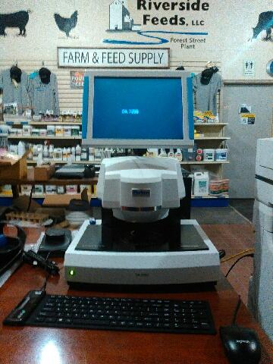

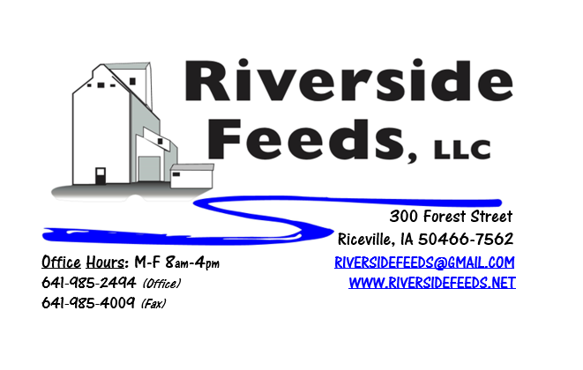
July 2019 Newsletter
Very exciting news this month! We have been able to secure the investment in a brand new Perten DA7250 Protein Analyzer instrument (pictured above)! This machine (about the size of a standard computer) scans any solid feed or grain material in any texture, and reads the moisture, protein, fat, fiber, starch, ash, among other nutritional data points. This instrument takes only 6 seconds to read a sample, and the results will be saved electronically and can be printed off. The benefits of this will be to save costs and time from using outside labs. Instead of waiting a week or two for a simple protein test to be done, we will now have a printed test result on EVERY product, EVERY time. This Certificate of Analysis will be sent to all customers with their Bill of Lading and truck scale ticket. Inventory products (such as our bagged poultry and swine feeds) will have test results available upon request. Our tests will be saved on our network for historical reference. This instrument is very expensive and will be handled with upmost care by trained staff only. We will begin the new testing procedures for every outbound load starting Monday, July 1st. If you have any questions about this, please feel free to contact us. We are proud to be able to offer a new customer service with providing test results on your ordered products!
Dr. Paul and Redmond Agriculture meeting will be at the Riceville Community Center in Riceville, IA, on Wednesday, July 24th! Meeting time will be from 9:30 am – 3:00 pm, with lunch provided. We would like to specifically thank our ingredient distributor, Hall Robert’s Son, Inc., for sponsoring the lunch at this meeting! This is an open meeting to all those interested. We will have 15% OFF Sale on ANY and ALL Dr. Paul’s Lab, Dr. Sarah’s Essentials, and Redmond Agriculture products for that day. This sale offering is good for walk in customers or phone/email orders placed ONLY on July 24th. Even if we do not have a certain product on the shelf, all orders will be included for the sale, placed on that day. Please see attached flier!
REMINDER: Saturday Hours during Summer months are by APPOINTMENT ONLY!
Organic Grain Prices:
We are expecting for organic corn prices to steadily rise as we near this fall’s harvest. We have heard major shortages of corn acres getting planted in Indiana and Ohio, and this could effect the organic corn market severely. Right now, organic corn is trading in the $9.25 - $10.50 range here in the Midwest.
Beans have fallen due to the low cost imported meal. Organic soybeans are trading between $17.50 - $19.50 a bushel here in the upper Midwest, and Wheat is around $8.50 - $9.00. Domestic organic Soybean Meal is trading around $775-$850 per ton. Barley is around $8.00 - $9.00. Oats are moving in the $5.00 - $7.00 per bushel.
Events Coming Up:
If there are field days or events that you would like to share with our customer base, please feel free to provide us the information and we will include it in next month’s newsletter!
- Practical Farmer’s of Iowa Field Days are taking place! Visit www.practicalfarmers.org
- We will be involved in local parade floats around the Riceville area! Watch for us!
- Dr. Paul’s Lab and Redmond Agriculture meeting – See attached flier!
Products We Offer:
We are long by about 100 tons of Non-GMO Soy Pro 50! This is a lot of product, and we are interested in moving this as soon as possible to help make space in the warehouse. We are willing to negotiate deals on full truckloads of this product. Soy Pro 50 is a fully cooked 50% or higher protein suited for all species of animals. It is low fat (5%). We are also long on Non-GMO Soy Pro 40 at this time, which is a high fat protein (excellent to feed in cold weather). Soy Pro 40 is a full fat, fully cooked, high bypass soy meal that can replace roasted soybeans. If you use roasted soybeans in your dairy cattle rations and are running low before harvest, this will work as a great replacement! Keep us in mind!
We also have liquid totes of Non-GMO soybean meal and soy oil blend (very wet saturated blend) available at a great price! This is a byproduct from an extruding plant, and we are looking for a home for this. This could be used as a fat source in multiple rations. We also have a couple totes of Non-GMO Soy Oil (no meal blend) available for sale too. Call today for more information!
Poultry Feeds:
We do have a few bags of chick starter available yet if needed. We have been moving a lot of layer and broiler grower feed recently. We also have a great inventory of SunCoast Pine Shavings for your bedding needs!
Swine Feeds:
We have a good supply of Organic Prewean 22 on hand and ready to send out. We also have Non-GMO Starter-Grower and Non-GMO Grower-Finisher pellets on hand in 50# bags! Show pig producers: Give us a call or stop by anytime to hear what products we may have for you!
Bovine Feeds:
We do have some Organic Calf Starter Pellets available. We also now have an organic milk replacer stocked on hand and ready for your use when needed! We also have a great supply of Organic Whole Milk Powder which could be used for a low-cost milk replacer for all animals. Please call today for more information!
Equine Feeds:
Multiple products available including our very own complete Horse Mix Pellets, Fertrell Horse Power Mineral, Equine Kelp, and Oat Screening Pellets. A lot of Dr. Paul’s and Dr. Sarah’s Essentials products are also great to use for all equine.
Dr. Paul’s Products:
As noted above, please mark your calendars for an upcoming production meeting, featuring Dr. Paul and Redmond Agriculture! We will have door prizes available at this meeting, as well as 15% OFF Sale on any Dr. Paul’s Lab, Dr. Sarah’s Essentials, and Redmond Agriculture products for that day only! We will allow orders to be placed on this sale.
Used Smidley Livestock Equipment Available:
We do have multiple options available for stainless steel hog bars. We can order any brand new Smidley livestock equipment. Smidley makes mineral feeders, steer stuffers, multiple sizes hog feeders (both stainless steel and wood), hog scales, hog huts, and livestock water fountains. We stock a full selection of Smidley livestock water fountain parts!
For Sale: Clipper 67D Cleaner with many screens for sale in excellent condition and ready to run. Asking $9,500 OBO. Schlagel Grain Distributor. 8”, double 24 hole swing. $5,000 OBO.

THANK YOU FOR YOUR BUSINESS!!!
“Revitalizing Industry Byproducts into Livestock Feed by
Recycling Organic and Non-GMO Grain Materials for Family Farmers”

