New signage in front of our office showing some of the agricultural companies that we are dealers for: Smidley, Dr. Paul’s, Redmond, Fertrell.

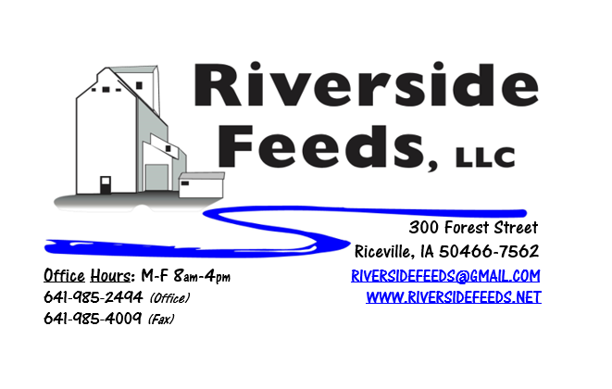
July 2018 Newsletter
Hello everyone! Northern Iowa has been excessively wet this spring and early summer, and we are hoping for some dryer days ahead. I’m curious how conditions are looking throughout the Midwest, as growing conditions can vary markets a lot. Thank you to those who sent back last month’s customer survey. If you still have the survey, you are welcomed to send it back anytime to be entered in a drawing for a gift certificate! You can send your survey back to us either by mail, fax, or email.
What’s Happening:
Thank you everyone for responding to our recent customer order fulfillment policy! Timely order placements and pickups are critical to us for being able to provide the best customer service possible.
We are now a dealer for Redmond Agriculture products! Since we have very limited space, we currently only have Redmond’s Conditioner Coarse and Udder Mud on hand (see price list), however, we are able to order in ANY Redmond products for your needs! Call today for more information!
Organic Grain Prices:
Organic grain prices have been slowly but steadily increasing since December. Corn is now trading in the $9.75 - $10.50 range, which has certainly increased since early winter. Barley is holding steady around $8.50.
Beans are trading between $19.00 - $21.00 a bushel here in the upper Midwest (Feed – Food, respectively, and Wheat is around $8.50 - $9.00. Soybean Meal is up a little, and is trading around $850-$900 per ton.
Events Coming Up:
If there are field days or events that you would like to share with our customer base, please feel free to provide us the information and we will include it in next month’s newsletter!
- Hybrid Rye and Industrial Hemp Field Day at Organic Valley’s Farm Plot, August 1st, La Farge, WI. Contact Tom or James Frantzen or Organic Valley for more details.
Products We Offer:
We are long on organic soy protein (Opro 40), and Non-GMO soy protein (SoyPro 50). Call and check in with me if we can fill any of your needs! We are long on Non-GMO Oat Screenings pellets (Not organic) available for sale yet, and can ship that out in bags, totes, or bulk quantities. We can ship any quantity out the door, and usually carry at least a few ton on hand. We also carry organic and conventional Apple Cider Vinegar, either in 4 gallon pails or 55 gallon drums. As always, we have a full line of vitamins and minerals. Kelp: Ocean Harvest Technology AKA Kelp has been on backorder, and I currently have Acadian on hand for the same price. Ocean Harvest Technology has species specific kelp (poultry, swine, bovine, equine). I do NOT carry the species specific kelp on hand, but can order it in at any time.

Poultry Feeds:
Starter season is getting close to an end, so let me know if you need any starter feed for late flocks. We offer Non-GMO Chick Starter (spring seasonal item), Non-GMO Broiler Grower, Non-GMO Poultry Layer, and Suncoast Pine Shavings (OMRI Approved). We do have a limited amount of Organic Layer Pellets in 50# sacks at this time. I do have a little Organic Chick Starter-Grower Crumbles left yet. We are eager to move this out soon. Please let us know of any interest in this, and the pricing is listed on the price list. If you are interested in a large quantity of these products, I may be willing to cut a deal! We also have Poultry Grit and Oyster Shells available for retail. Dr. Paul has Poultry Plus and Poultry X for your poultry health needs!
Swine Feeds:
Call today to place your order on any swine feed products. Reminder – we have a minimal production run for our mill, but we could split a few orders up with other customers. We have been getting a lot of orders from show pig producers for pine shavings and trying some of Dr. Paul’s products out! Protect Her is a great product for hair coats, and I think it would work great on all show stock to keep the skin moist and hair coats looking good! Dr. Paul has PigAde and Swine X for your swine health needs!
Bovine Feeds:
We recently made organic Calf Starter 14% Pellets, and this worked VERY well on our organic beef calves this spring. I can make adjustments to the protein percentage for your calf diet needs. These pellets are very sturdy and sweet, and I can make this using Non-GMO ingredients as well. Oat screenings can be a good grain extender and fiber filler for all bovine, and also equine. We are long on Non-GMO oat screenings – call today to place your order! Dr. Paul has MANY items for bovine uses, especially calf start, CGS Remedy, S&G Pills (good for sheep, goats, and calves), and Detox for your bovine health needs!
Horse Feeds:
Our new Horse Mix Pellets are going over very well, and we are excited to make more batches of this up as the demand steadily increases! We do carry the horse feed on hand, so stop by today or call to place your order! As mentioned above, Protect Her is a great product to use for skin moisturizer and hair coat on horses. Shoo-Fly spray also works well for keeping the flies off of all animals.
Dr. Paul’s Products:
We are now offering monthly sales special on Dr. Paul’s products throughout the summer. July is “Aloe” month, and we will be selling Aloe-C in gallon size, Herbaloe (32 ounce), and Aloe Pellets in 3.5# and 25# sizes (50# sacks are excluded) for 10% off! Aloe is a very good product that boosts immune systems in all species, especially during stressful times (calfing, farrowing, shipping, etc.). This is allowed for organic use, as well as all of Dr. Paul’s products. Dr. Paul’s Aloe Pellets are certified organic through MOSA.
Used Smidley Livestock Equipment Available:
We are looking for good, used Smidley hog scales and waterers. We currently have a few used waterers with new parts on hand but used fountain supply is limited. We can also order any brand new Smidley livestock equipment. Smidley makes mineral feeders, steer stuffers, multiple sizes hog feeders (both stainless steel and wood), hog scales, hog huts, and livestock water fountains. We stock a full selection of Smidley livestock water fountain parts!

THANK YOU FOR YOUR BUSINESS!!!
“Revitalizing Industry Byproducts into Livestock Feed by
Recycling Organic and Non-GMO Grain Materials for Family Farmers”

