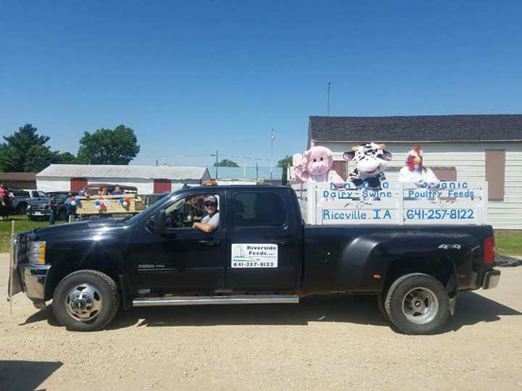
Alta Vista Days Parade Float on June 3rd. I’m hauling a bunch of goofy livestock!

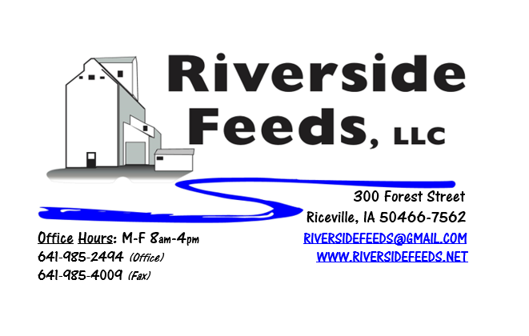
June 2017 Newsletter
Hi everyone! In regards to providing superior customer service and support to all of our dedicated customers, we have decided to do our best at sending a monthly newsletter out. This takes some work on our end for writing and mailing out, but we would like to provide you with the most information possible about what products we have on hand, services we offer, and what’s new here at Riverside Feeds! We take pride in the work that we do here, and greatly appreciate your support towards this business. Each month, I’ll express what we do here, what we have going on, and some not so usual blends or products that we may be working with. I’ll also include an updated price list for our products. We do have several sources for our products, so if we don’t have something on hand, please feel free to ask.
What’s Happening:
Lately, we have been very busy with our general grinding, mixing, and pelleting duties. We have been moving more tons in the recent months than ever before in our history, partly because we have our new pellet mill up and running with very few issues, and partly because we are able to provide a larger variety of custom grinds and blends (some of this is complete feeds, but some is ingredient blends). We are working towards including Ground Oat Screenings in as many products as possible since we have a large source of this ingredient, and it’s cheap. Ground Oat Screenings can replace corn for ruminant animals. If your dairy market is long on milk right due to the spring flush, you may want to consider this as an alternate ingredient in your pellets to help slow down the protein and to replace some high price corn.
Organic Grain Prices:
In the recent few weeks, organic corn has gone up slightly into the $9 range, some bids were as high as $10 per bushel. Soybeans remain steady with feed grade around $16 - $17.50 per bushel, food beans are at the usual premium above that, depending on which marketing company you’re asking for a bid from. With the increase in organic corn prices, this will put a slight burden on the livestock producers, so watch your wastage and quality of grain to maintain maximum efficiencies.
Services We Offer:
As most of you may know, we do have a hammer mill for grinding any solid state materials, a 4 ton ribbon blender for mixing products, and a pellet mill for pelleting feed products. We currently have two pellet dies – 1/8 inch, and a 3/16 inch. All cattle pellets are going through the 3/16 inch, but I may order another larger die sometime this summer for making mini cubes for sow feed or pasture pellets. We can pellet any products on a custom basis as well – bring it to me, and we will pellet it! We also have bagging operations, so not all products have to go out in the bulk form. We can fill feed sacks or tote bags for a specific fee. We also have a full truck and trailer fleet. We have a few trucks to assist with transportation needs: “Big Blue” and “Lil Blue” are our two semi tractors, and “Straight Blue” is our newest addition, which is a 15 ton feed truck (Yes, all three trucks are blue!). We also have a couple heavy pickup trucks for pallet items. We do have a line of hopper bottom trailers, a van trailer, and a flatbed trailer. For additional transportation needs, we have a list of carriers who we work with on a weekly basis.
Events Coming Up:
*See us in some local town parades this summer! We will be advertising our business with our parade float in the Colwell Day Parade on July 8th, Old Roundhouse Trail Days (Elma) Parade on July 22, and Wapsi Days (Riceville) on August 5th. If you are in the area, please help support these small towns and their annual celebrations! We had a great time this past weekend at the Alta Vista Days Parade on Saturday, June 3rd.
*Practical Farmers of Iowa Field Day at Frantzen Farm – “Two New Grains and Their Uses: Hybrid Rye and Kernza”, Thursday, June 29th 2 – 5 pm, New Hampton, IA.
*Practical Farmers of Iowa Field Day at Rosmann Family Farm – “Pigs and Water Quality”, Saturday, September 9th 1 – 4:30 pm, Harlan, IA.
If there are other field days or events that you would like to share with our customer base, please feel free to provide us the information and we will include it in next month’s newsletter!
Products We Offer:
As mentioned, we have been working a lot with ground oat screenings, and some customers are experimenting with a new blend of soy hulls and oat screenings, which we call “Cattle Pro”. We also have organic wheat midds on hand, ready for sale. We are long on organic soy hulls as well, but this can change in a fast pace at times. We do carry organic and conventional Apple Cider Vinegar, either in 4 gallon pails or 55 gallon drums. We also have organic soy oil on hand at all times. As always, we have a full line of vitamins and minerals. We are a dealer of Crystal Creek products as well as Smidley equipment.
Poultry Feeds:
We have a full line of complete Non-GMO Poultry Feeds (not organic at this time). We have Broiler Starter, Broiler Grower, and Layer Feed. We also carry SunCoast Pine Shavings for your bedding needs. The pine shavings are OMRI Approved. We may experiment with pelleting the layer and grower feed real soon to increase the quality of the feed, yet maintain the same price. Stay tuned for more information on this!
Swine Feeds:
We are getting into doing a lot more complete organic hog feeds for a few customers on a custom ration basis. This complete feed is ground, mixed, and pelleted, and sent out either in bags, totes, or bulk. Our newest experiment is a missing link in the organic pork industry called “Riverside’s Prewean 22 Pig Feed Pellet”. Prewean 22 is a creep feed pellet for young pigs prior to weaning. This can be fed at weaning time as well, but it is an expensive feed due to the different ingredients. It does contain dried buttermilk powder, which is very good and highly digestible for pigs at this age. It is a 22% protein in the pelleted form and in 50# bags, retailing for $26.50 per bag. Not many pounds are needed for each pig, however, I feel that this is a VERY important feed, and our goal is to wean heavier pigs, and finish hogs maybe a week or two earlier. This should also help reduce sow breed-back issues (keep sows in better condition). Please call for more information on this. We do have some on hand right now if you would like to try some, but it is currently in the testing stage.
Used Smidley Equipment Available:
Single drinker, single sided (1 hole) – We have 6 on hand. Single drinker, double sided (2 hole) – We have 3 on hand. Double drinker, double sided (4 hole) – 2 on hand. Triple drinker, double sided – (6 hole) – 1 on hand. We are looking for good, used Smidley hog scales. We can also order any brand new Smidley equipment, but they are way behind on manufacturing, so it may take a couple months to get a new feeder or piece of equipment. Please call for pricing on the drinkers.

THANK YOU FOR YOUR BUSINESS!!!
*Please see attached price sheet for current prices on products. Please call the office with any orders or questions.

