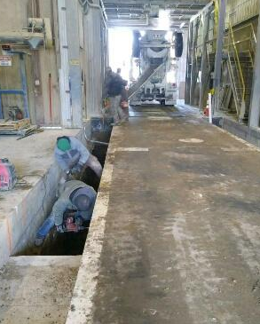

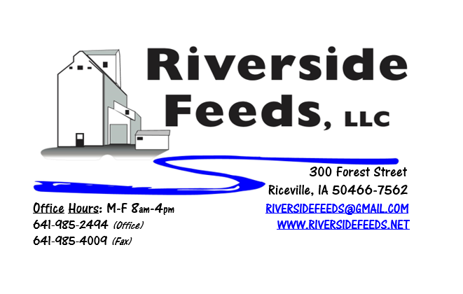
March 2019 Newsletter
Construction has begun! Even though we are still battling some severe cold weather and a lot of snow, we were able to find time to pour 44 yards of concrete in late February for the foundation needed for new overhead load out bins! As pictured, the foundation for the bins are in the ground on both sides of our truck scale inside of the mill. This was a challenging dig and pour, but all went well. We were completely shut down from production for only one day!
We greatly appreciate everyone’s cooperation during the cold weather. The cold temperatures really slow everyone down, and we struggle with missing outbound trucks and slow moving equipment. We rely on patience and cooperation and the hope for warmer temperatures soon!
Please see below in the events section about a local meeting coming up in the Elma/Riceville, Iowa, area about Hybrid Rye production. Many folks around here have been asking about Hybrid Rye, and in partnership with another topic, we will have a short presentation on this new crop! Details are being finalized, so please call and stay tuned about this in the next few weeks.
LAST REMINDER! We highly encourage anyone and everyone who is producing organic hogs or may have some thoughts about starting up organic pork production to make every attempt possible to attend a brand-new conference coming this weekend! Iowa Organic Association will be putting on the first ever “Midwest Organic Pork Conference” in Waterloo, Iowa, this Friday and Saturday, March 8th & 9th. This conference needs attendees and exhibitors to get the first year off to a great start! If interested, please register to attend online at www.midwestorganicporkconference.org or onsite registrations are welcomed. This will be located at the Waterloo Center for the Arts. If you have any questions, please feel free to ask me.
Riverside Feeds is a major sponsor and exhibitor of the Midwest Organic Pork Conference! We will be at this conference throughout the entire duration and will have plenty of swine related information available at our booth, including some of Dr. Paul’s products that can be used for pigs! I will be giving a presentation on efficient and effective housing options for organic swine, and some of our customers will also be speaking at this conference including Jude Becker, Dan Wilson, Tom Frantzen, and Ron Rosmann!

Organic Grain Prices:
Organic corn is now trading in the $9.75 - $10.50 range. Barley is holding steady around $8.50.
Beans have fallen due to the low cost imported meal. Organic soybeans are trading between $17.00 - $19.00 a bushel here in the upper Midwest, and Wheat is around $8.50 - $9.00. Domestic organic Soybean Meal is trading around $775-$850 per ton.
Events Coming Up:
If there are field days or events that you would like to share with our customer base, please feel free to provide us the information and we will include it in next month’s newsletter!
- Midwest Organic Pork Conference, Waterloo, IA. March 8 – 9, 2019. (Read more above!)
- The Gathering, Mason City, IA. March 16th, 2019. “Coming together around local food”
- Career Expo, Riceville High School. March 21st, 2019.
- Fertilizer and Hybrid Rye Meeting, Late March near Riceville/Elma area! Please call for more details or ask Marvin Newswanger or Mervin Beachy.
Products We Offer:
We are long on Non-GMO soy proteins (Not organic) available for sale yet, and can ship that out in bags, totes, or bulk quantities. We are especially long on Soy Pro 40 at this time, which is a high fat protein (excellent to feed in cold weather). Also remember that we have Redmond salt on hand, as well as many other minerals, vitamins, and micro ingredients.
Poultry Feeds:
We have started to update our poultry rations recently, including adding humates (Reed Sedge Peat) in the ration to prevent scours and boost immunity. You may notice that our poultry feed will now look a little darker in color due to this change. We will be making chick starter up this week to have on hand and ready to go out, however, I highly recommend for you to hold off on getting chicks until this crazy weather turns around.
Swine Feeds:
We have a good supply of Organic Prewean 22 on hand and ready to send out. We will soon carry a new line of Non-GMO swine feeds in 50# bags! We also recommend using Reed Sedge Peat (humates) as a prevention of scours as well for little pigs.
Bovine Feeds:
Keep in mind the benefits of Aloe Pellets and high energy sources like Molasses when feeding calves and any bovine during colder and varying temperatures. Aloe Pellets can help with fevers, pneumonia, and stress. We may have some serious struggles with spring calving this year due to the extended winter conditions. Keep a close watch over their health and performance, and keep in mind that calf blankets can be very beneficial in this cold weather! We do have some Organic Calf Starter Pellets freshly made up and on hand now. We also now have an organic milk replacer stocked on hand and ready for your use when needed!
Horse Feeds:
We have a good supply of our complete Non-GMO Horse Pellets on hand, which have been working great for work horses. This product includes minerals and molasses, among a list of ingredients. We also have oat screening pellets available in bags, totes, or bulk. This has been working very well to replace expensive hay currently.
Dr. Paul’s Products:
*NEW PRODUCT: Arnica Ice Lotion! This is a deep warm cooling treatment (like icy hot). When using this product, massage it well onto sore muscles, injured or inflamed joints, and bruised or infected tissue. We now carry this in both 8 and 16 ounce sizes!
Used Smidley Livestock Equipment Available:
We do have some 4 drink hog bars on hand, and a cattle mineral feeder. We can order any brand new Smidley livestock equipment. Smidley makes mineral feeders, steer stuffers, multiple sizes hog feeders (both stainless steel and wood), hog scales, hog huts, and livestock water fountains. We stock a full selection of Smidley livestock water fountain parts!
For Sale: Smidley Cattle Mineral Feeder with attached oiler (fly control) system for sale - $800 OBO. We also have a Clipper 67D Cleaner with many screens for sale in excellent condition and ready to run. Asking $10,000 OBO. Motivated to move both items soon!

THANK YOU FOR YOUR BUSINESS!!!
“Revitalizing Industry Byproducts into Livestock Feed by
Recycling Organic and Non-GMO Grain Materials for Family Farmers”

