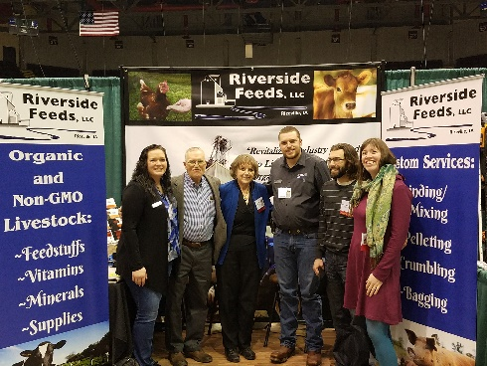
Pictured is the Rosmann Family, Organic Farmer of the Year Award Winners, standing in our new exhibit booth at the Organic Farming Conference in LaCrosse!

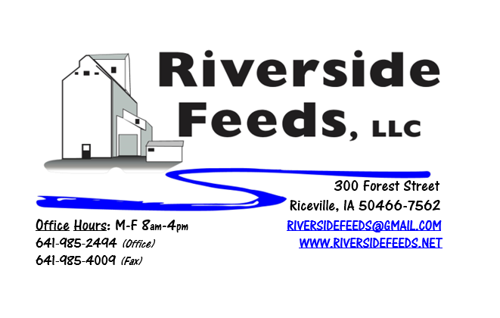
March 2018 Newsletter
This has been a very exciting month! Beyond the very nice weather lately that has brought us some warmer temperatures, we had a lot of great surprises! First, we were notified that there was an opening for an exhibit booth for the Organic Farming Conference in LaCrosse! We have been on the waiting list for a few years now, and the long wait was well worth it. Pictured above is our new exhibit booth, with all new signage and banners! Second surprise for us was that one of our long-time customer family was awarded the Organic Farmer of the Year at the OFC Conference! This made for a very fun time in LaCrosse last weekend!
What’s Happening:
Our retail store has been taking off very nicely, and we have been moving a lot of Dr. Paul products recently! We do now have Reed Sedge Peat Humates available in 50# bags. Check out our price list (back side is all of our retail products).
Since we are a dealer of Dr. Paul’s Lab, we will be having a dealer meeting with Dr. Paul this spring! We are very excited to see Dr. Paul join us on Thursday, March 29th, at the Cedar Valley Produce Auction near Elma, IA (just south of Riceville 8 miles). More information about this is included with this month’s newsletter (see enclosed).
Also enclosed, please find our updated and freshly printed brochure! Take time to read through this and enjoy learning what we all have to offer.
Organic Grain Prices:
Organic grain prices have been slowly but steadily increasing since December. Corn is now trading in the $9.00 - $10.00 range, which has certainly increased since last month. Barley has also gone up a little too - $8.50 - $9.00.
Beans are trading between $19.00 - $21.00 a bushel here in the upper Midwest (Feed – Food, respectively, and Wheat is around $8.50. Soybean Meal is trading around $800-$825 per ton.
Services We Offer:
Please contact us if you or anyone who you know may be looking for custom pelleting options. Our services now include: Warehousing (including loading dock), Hammer mill, Mixer, Pellet Mill, Crumbler, and load out in either bulk, tote bags, or feed sacks. We also have a fleet of trucks and trailers. We have been receiving many phone calls from large feed and food grade operations looking for custom organic pelleting, and are glad to be available to help fill this demand! We also have a nicely displayed and stocked retail shelf in our front office with hard to find farm supply items, focused towards our customers’ needs (OMRI listed, certified organic, or approved for organic use). This includes Dr. Paul’s products, Smidley fountain parts, All-Weather paintsticks, and more!

Events Coming Up:
If there are field days or events that you would like to share with our customer base, please feel free to provide us the information and we will include it in next month’s newsletter!
- Dr. Paul Meeting, sponsored by Riverside Feeds, Thursday, March 29th at the Cedar Valley Produce Auction near Elma, IA. This meeting will run from 10 – 2, with lunch provided, plus an hour social/question & answer time before and after the meeting. We will have retail items available for sale at this meeting including kelp, humates, Aloe pellets, barn lime, shavings, poultry feeds, and the full Dr. Paul’s line of products. We will have discounted pricing at this meeting, so be ready for some great deals!
Products We Offer:
We are long on organic soy hulls and screenings, and soy protein. Call and check in with me if we can fill any of your demand! We are focusing on selling our custom services (grinding, mixing, pelleting) now. We do have more Non-GMO Oat Screenings pellets (Not organic) available for sale yet. We also carry organic and conventional Apple Cider Vinegar, either in 4 gallon pails or 55 gallon drums. As always, we have a full line of vitamins and minerals. I do carry Organic Liquid Molasses in 50# pails, or 275 gal totes. We have Smidley water fountain parts on hand at all times. Dr. Paul’s products are on hand and available to be ordered. We now have Reed Sedge Peat Humates on hand. For those who are interested in other options, I can order in Fertrell “Live Earth” Humates, and Acadian Kelp.
Poultry Feeds:
Our poultry feeds are all in crumbled form. We offer Broiler Starter (spring seasonal item), Broiler Grower, Poultry Layer, and Suncoast Pine Shavings (OMRI Approved). We DO have a limited amount of Organic Layer pellets and Organic Chick Starter Pellets, both in 50# sacks. We have about 3 ton of each, and are eager to move this out soon. Please let us know of any interest in this, and the pricing is listed on the price list.
Swine Feeds:
Pre-wean 22 pig feed pellets make a GREAT starter creep feed pellet for young pigs and should be offered especially during colder winter farrowing months. We carry a few bags on hand, but larger orders must be requested and given a few days in order to work into our schedule to make. We do have All-Weather Paintsticks on hand now in our retail store for hog markers. We have multiple colors – Blue, Red, Orange, and Fluorescent Green. We can send a case of markers with your product order at anytime!
Dr. Paul’s Products:
Aloe C is a liquid substance that comes in a one gallon jug, and is used as an immune boost, and to be used whenever infection or virus is present. The ingredients are liquid Aloe Vera with Vitamin C and Rose Hips. If Apple Cider Vinegar is not working, this would be the next best product to try. This can easily be added into the water supply, or blended with feed.
Used Smidley Equipment Available:
We are looking for good, used Smidley hog scales and waterers. We can also order any brand new Smidley equipment. Pricing on Smidley parts and used equipment is listed on the retail price sheet. We have a great selection of Smidley water fountain parts!

THANK YOU FOR YOUR BUSINESS!!!
“Revitalizing Industry Byproducts into Livestock Feed by
Recycling Organic and Non-GMO Grain Materials for Family Farmers”

