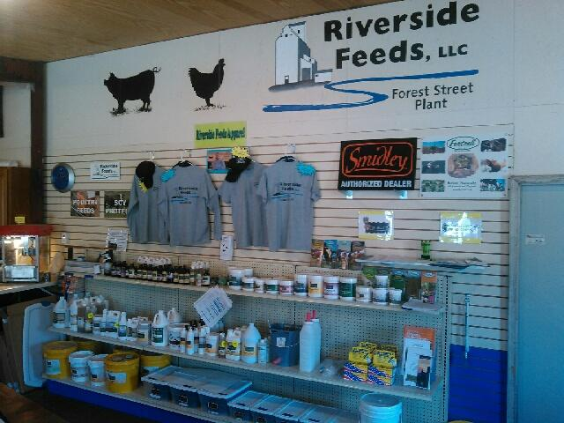
Our newly organized retail store shelf! We now carry a variety of hard-to-find farm supply items, including Dr. Paul’s, Crystal Creek, Smidley, Fertrell, All-Weather, and more!

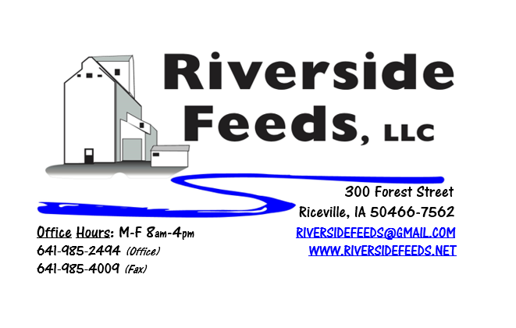
February 2018 Newsletter
It sure has been a busy winter here at Riverside Feeds! We have been traveling to a few farming conferences, continue to pellet record amounts of byproducts, and have been busy building up our retail store and filling our new shelves! Besides the large variety of Dr. Paul’s products and Smidley water fountain parts, we now have a few hard-to-find farm supplies including calf milk bottles and buckets, livestock paint sticks, and will hopefully continue to supply the shelf with other products including chicken feeders and waterers, and maybe even some swine nose rings and pliers! Stay tuned in our retail products listing. Starting this month, our retail products listing will be on the back of our general price list. Please also note a new section to this newsletter, Dr. Paul’s Products! Each month, I’ll briefly explain one of his products that we carry.
What’s Happening:
As I mentioned, we are trying to source competitively priced farm supplies that are hard to find, and fit into our customer base. Our retail store is a work in progress, but it has been showing a lot of merit and we are super excited to offer such products! If you have time to swing by and visit, I think you’ll be impressed!
Since we are a dealer of Dr. Paul’s Lab, we will be having a dealer meeting with Dr. Paul this spring! Please see the enclosed save-the-date card for this meeting, which will take place on Thursday, March 29th, at the Cedar Valley Produce Auction near Elma, IA (just south of Riceville 8 miles). More information about this will come next month.
Also enclosed, please find our updated Organic Certificate. On the back side of the certificate, you should find our Certified Organic Products and Services sheet.
Organic Grain Prices:
Organic grain prices have been slowly but steadily increasing since December. Corn is now trading in the $8.50 - $9.75 range, which has certainly increased since last month. Barley has also gone up a little too - $8.00 - $8.50.
Beans are trading between $18.00 - $20.00 a bushel here in the upper Midwest (Feed – Food, respectively, and Wheat is around $8.50. Soybean Meal is trading around $800 per ton.
Services We Offer:
Please contact us if you or anyone who you know may be looking for custom pelleting options. Our services now include: Warehousing (including loading dock), Hammer mill, Mixer, Pellet Mill, Crumbler, and load out in either bulk, tote bags, or feed sacks. We also have a fleet of trucks and trailers. We have been receiving many phone calls from large feed and food grade operations looking for custom organic pelleting, and are glad to be available to help fill this demand! We also have a nicely displayed and stocked retail shelf in our front office with hard to find farm supply items, focused towards our customers’ needs (OMRI listed, certified organic, or approved for organic use).
Events Coming Up:
If there are field days or events that you would like to share with our customer base, please feel free to provide us the information and we will include it in next month’s newsletter!
- MOSES Organic Farming Conference, La Crosse, WI. February 22nd – 24th. We are on the “waiting list” to exhibit at this conference, so please share with conference staff that you want to see Riverside Feeds exhibiting at this conference! Amanda and I will both be attending this conference. We will hopefully have our booth at this conference in the near future!
- Dr. Paul Meeting, sponsored by Riverside Feeds, Thursday, March 29th at the Cedar Valley Produce Auction near Elma, IA. Time has not been confirmed yet, but this will be a daytime meeting with lunch included. We will have retail items available for sale at this meeting including kelp, humates, Aloe pellets, barn lime, shavings, poultry feeds, and the full Dr. Paul’s line of products. We will have discounted pricing at this meeting!
Products We Offer:
We just recently got some more organic soy proteins in, however, supplies are still fairly tight. Sales have been very good recently, and we have a large demand for many products. We are focusing on selling our custom services (grinding, mixing, pelleting) now. We do have more Non-GMO Oat Screenings pellets (Not organic) available for sale yet. We do carry organic and conventional Apple Cider Vinegar, either in 4 gallon pails or 55 gallon drums. As always, we have a full line of vitamins and minerals. I do carry Organic Liquid Molasses in 50# pails. We also carry Crystal Creek “No-Fly” on hand. Otherwise, orders can be placed through us for any Crystal Creek or Smidley Equipment products. We have Smidley water fountain parts on hand at all times. Dr. Paul’s products are on hand and available to be ordered. We will have Reed Sedge Peat Humates on hand by later this week!
Poultry Feeds:
Our poultry feeds are all in crumbled form. We offer Broiler Starter (spring seasonal item), Broiler Grower, Poultry Layer, and Suncoast Pine Shavings (OMRI Approved).
Swine Feeds:
Pre-wean 22 pig feed pellets make a GREAT starter creep feed pellet for young pigs and should be offered especially during colder winter farrowing months. We carry a few bags on hand, but larger orders must be requested and given a few days in order to work into our schedule to make. We do have All-Weather Paintsticks on hand now in our retail store for hog markers. We have multiple colors – Blue, Red, Orange, and Fluorescent Green. We can send a case of markers with your product order at anytime!
SwineX is an organic swine wormer from Dr. Paul’s Lab. I have just started to use this product myself, and so far, I am impressed with how well young pigs and full size sows consume this as a top dress to my feed. It’s too early to say much about the results of using this, but I do have customers who are firm believers in using SwineX.
Dr. Paul’s Products:
Aloe Pellets is a nutritional supplement for animals (all species) that consists of corn, wheat midds, alfalfa meal, molasses, kelp, aloe extract, garlic extract, calcium carbonate. This is certified organic and is used as either force feed, top dress, or free choice. Aloe Pellets helps increases immunity levels and is commonly used for shipping fever.
Used Smidley Equipment Available:
We are looking for good, used Smidley hog scales and waterers. We can also order any brand new Smidley equipment. Pricing on Smidley parts and used equipment is listed on the retail price sheet.

THANK YOU FOR YOUR BUSINESS!!!
“Revitalizing Industry Byproducts into Livestock Feed by
Recycling Organic and Non-GMO Grain Materials for Family Farmers”

