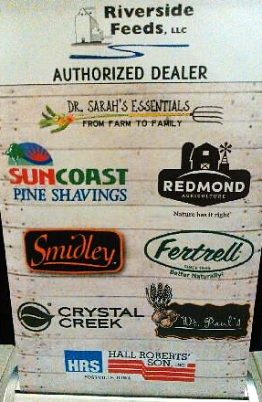
Our new display banner for the exhibit booth showing all the brands of retail products we stock! Dr. Sarah’s Essentials, SunCoast, Redmond, Smidley, Fertrell, Crystal Creek, Dr. Paul’s, and Hall Robert’s Son.

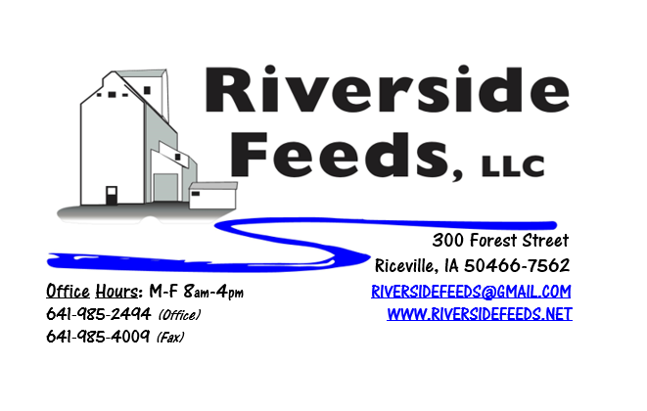
December 2019 Newsletter
Happy Holidays everyone! Winter is now here as we continue to fight extremely wet field conditions and there is a lot of fall harvest yet to be completed. Hopefully the weather turns around for the better and some of us can finish up with corn harvest before the snow gets too deep. We really need dry conditions in the Upper Midwest. As we enter the time of the year of dangerous road conditions, we ask for everyone’s patience while we work around Mother Nature to deliver feed products to our customers. It may take an extra day or two before you can get your order – so please ORDER EARLY!
We have experienced a never-ending list of phone calls from current and new customers wanting our Non-GMO Oat Mill Run Pellets for a fiber source this fall and winter. Unfortunately, this large supply is running short and has already been consumed up by past customers. We are running extremely tight on supply and had to cut very recent new customers off completely, which is a very hard and stressful job to manage here. If we were to meet all current demand, we would need at least double the current supply that we are pelleting. I’m very sorry to report this, but it is illegal for me to sell “thin air” to you when the bin runs out, so we have no option but to cut back to all customers and restrict the new sales. We ask for all current consumers of the Non-GMO Oat Mill Run Pellets to cut back on feeding rates, as the price will continue to climb this winter and the supply shortage may or may not turn around. The inbound supply depends on oat cleanings and percent of byproduct by processing oats from our supplier. Please take note at the updated price list, and prices have increased for some products, including Non-GMO Oat Mill Run Pellets.
We ask for all customers who wish to pay their feed bills at the end of the year to do so in a timely manner. Please do NOT wait until the last day of the year if you wish for your payment to be processed in 2019. Take note of our holiday schedule that is enclosed with this newsletter. Also take note that James and Amanda will be taking off for an extended vacation at the end of this year. We will be leaving the office at Noon on Christmas Eve, and will not be returning until Monday, January 6th. * We will NOT be available by cell phone! * All orders and inquiries must be directed straight to the office, like usual. I will not be available to take any overnight or weekend calls, so please work with us and make your request present to my office staff during normal business hours. Amanda and I have faith in our highly skilled and talented employees to take care of all issues in our absence. Please contact me prior to Christmas Eve for any year end business.
Organic Grain Prices:
Reminder: We are not a grain elevator, thus, we do NOT trade grains. I may use a very small amount of grain for some feeds from time to time, but we are full on our needed supply for now. I’ll have some updated grain pricing information next month as harvest will hopefully be wrapped up.
Events Coming Up:
If there are field days or events that you would like to share with our customer base, please feel free to provide us the information and we will include it in next month’s newsletter! We will be attending the following conferences with our exhibit booth:
- MN Organic Conference, January 9th – 11th, St. Cloud, MN.
- Practical Farmer’s of Iowa Annual Meeting, January 16th – 18th, Ames, IA
- Northern Plains Organic Conference, January 23rd – 25th, Fargo, ND
Products We Offer:
Need soy protein? We have multiple options available right now of Non-GMO Soy Pro 40, Soy Pro 50, and Soy Pro 55! We are willing to negotiate deals on full truck load quantities of these products. If you are running short on roasted beans or a good fat source in your rations this winter, Soy Pro 40 makes a great replacement!
We also have liquid totes of Non-GMO soybean meal and soy oil blend (very wet saturated blend) available at a great price! This is a byproduct from an extruding plant, and we are looking for a home for this. This could be used as a fat source in multiple rations. We also have a couple totes of Non-GMO Soy Oil (no meal blend) available for sale too. This oil can be used as a fat source for multiple species. Call today for more information!
We have a steady supply of Non-GMO Soy Hulls available to move. Consider using soy hulls as a replacement for the shorted Oat Mill Run Pellets!
Poultry Feeds:
SunCoast Pine Shavings make great bedding packs in nesting boxes for poultry. Stock up on a few extra bags of shavings to keep your birds warm this winter! As always, our Layer and Broiler Grower feeds are always on hand.
Swine Feeds:
Currently in stock: Non-GMO Swine Starter-Grower Pellets, Non-GMO Swine Grower-Finisher Pellets, and Organic Prewean 22 Pellets. We also carry many swine feed ingredients including organic steamed rolled oats, organic buttermilk powder, organic alfalfa meal, and more!
Bovine Feeds:
We have an organic milk replacer stocked on hand and ready for your use when needed! Our organic buttermilk powder can be used as a cheap milk replacer for young animals. Redmond has a Beef Mineral mix that we have on hand. We also stock Redmond salt and salt blocks.
Equine Feeds:
We are VERY SHORT on Non-GMO Oat Mill Run Pellets – please call to discuss options.
Dr. Paul’s Products:
Our exhibit booth this winter at various farming conferences will include the new Dr. Paul’s Lab Catalog! This well illustrated catalog is a must have for those who are looking for alternative treatments. If you would like to receive a free catalog in the mail from us, please give us a call.
Used Smidley Livestock Equipment Available:
We do have multiple options available for USED stainless steel hog bars. We have single drinks, 2 drinks, 4 drinks, and a 6 drink available for reasonable prices. These used hog bars are all packed with brand new electrical and plumbing parts.
We can order any brand new Smidley livestock equipment. Smidley makes mineral feeders, steer stuffers, multiple sizes hog feeders (both stainless steel and wood), hog scales, hog huts, and livestock water fountains. We stock a full selection of Smidley livestock water fountain parts! We can also order in any Smidley Feeder parts.
For Sale: Clipper 67D Cleaner with many screens for sale in excellent condition and ready to run. Asking $9,500 OBO. Will clean many different grains and is easy to run. Schlagel Grain Distributor. 8”, double 24 hole swing. $3,000 OBO. Bobcat Backhoe attachment (attaches to Bobcat 2400 Wheel Loader) in very nice condition. $3,000 OBO. Call for more information!
THANK YOU FOR YOUR BUSINESS!!!
“Revitalizing Industry Byproducts into Livestock Feed by
Recycling Organic and Non-GMO Grain Materials for Family Farmers”

