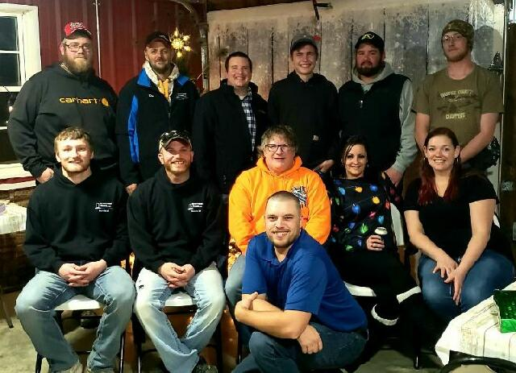

January 2020 Newsletter
Happy New Year Everyone! Pictured above is our current staff attending our Holiday Party in December. We really appreciate all the support and business from all our vendors and customers last year, and we are looking forward to another very successful year with more growth to come! Please also keep in mind during the winter months to ORDER EARLY as we must work with mother nature, and we can easily fall behind on our trucking schedule due to road conditions.
We have experienced a never-ending list of phone calls from current and new customers wanting our Non-GMO Oat Mill Run Pellets for a fiber source this fall and winter. Unfortunately, this large supply is running short and has already been consumed up by past customers. We are running extremely tight on supply and had to cut very recent new customers off completely, which is a very hard and stressful job to manage here. If we were to meet all current demand, we would need at least double the current supply that we are pelleting. I’m very sorry to report this, but it is illegal for me to sell “thin air” to you when the bin runs out, so we have no option but to cut back to all customers and restrict the new sales. We ask for all current consumers of the Non-GMO Oat Mill Run Pellets to cut back on feeding rates, as the price will continue to climb this winter and the supply shortage may or may not turn around. The inbound supply depends on oat cleanings and percent of byproduct by processing oats from our supplier. Please take note at the updated price list, and prices have increased for some products, including Non-GMO Oat Mill Run Pellets.
Reminder: James and Amanda will be out of the area for a much-needed vacation now through January 5th. We will be back in the office on the 6th. However, please continue to direct all calls and inquires through our main office number, as I’ll be traveling to many organic farming conferences over the next few months. My available time will be very limited, but I trust my staff to answer all your questions.
Also, in December, we had an employee Chili Cook-off competition! This was a fun experience for some of our crafty chefs, and we had 11 different pots of chili to sample from. We charged $5 per person to come in and sample, then vote. All proceeds were matched by Riverside Feeds, and donated towards Riceville non-profit groups, determined by the winning chef. First Place was Tim Shane, who is our Plant Manager, and he decided to donate towards the Riceville Athletic Boosters. Second Place was Dan Warnke, our truck driver and feed mill operator, and he decided to donate towards Riceville Ambulance. James Frantzen, CEO, won Third Place and I decided to donate towards Riceville Fire Department.
Organic Grain Prices:
Reminder: Corn harvest has finally wrapped up. I haven’t heard many changes in prices around the Upper Midwest. Organic corn is trading around $9 - $9.50 per bushel. Soybeans are $18.50 - $19.50 feed grade, $21-$23 food grade.
Events Coming Up:
If there are field days or events that you would like to share with our customer base, please feel free to provide us the information and we will include it in next month’s newsletter! We will be attending the following conferences with our exhibit booth:
- MN Organic Conference, January 9th – 11th, St. Cloud, MN.
- Practical Farmer’s of Iowa Annual Meeting, January 16th – 18th, Ames, IA
- Northern Plains Organic Conference, January 23rd – 25th, Fargo, ND
- Organic Farming Conference, February 27th – 29th, La Crosse, WI
Products We Offer:
Need soy protein? We have multiple options available right now of Non-GMO Soy Pro 40, Soy Pro 50, and Soy Pro 55! We are willing to negotiate deals on full truck load quantities of these products. If you are running short on roasted beans or a good fat source in your rations this winter, Soy Pro 40 makes a great replacement!
We also have liquid totes of Non-GMO soybean meal and soy oil blend (very wet saturated blend) available at a great price. This is a byproduct from an extruding plant, and we are looking for a home for this. This could be used as a fat source in multiple rations. We also have a couple totes of Non-GMO Soy Oil (no meal blend) available for sale too. This oil can be used as a fat source for multiple species. Call today for more information!
We have a steady supply of Non-GMO Soy Hulls available to move. Consider using soy hulls as a replacement for the shorted Oat Mill Run Pellets! Please call us with your needs on Non-GMO Oat Mill Run Pellets, as the list is very limited.
Complete Feeds:
We have multiple feeds on hand and ready for you to pick up anytime. This includes our Non-GMO Poultry and swine feed pellets, Organic Prewean 22 pig feed pellets, and Non-GMO Horse Mix Pellets. We also carry MANY ingredients to make your own feed, including organic steamed rolled oats, organic buttermilk powder, organic alfalfa meal, and many vitamins and minerals.
Retail Products:
Our exhibit booth this winter at various farming conferences will include the new Dr. Paul’s Lab Catalog! This well illustrated catalog is a must have for those who are looking for alternative treatments. If you would like to receive a free catalog in the mail from us, please give us a call.
We also carry Redmond, Crystal Creek, Dr. Sarah’s Essentials, and Apple Cider Vinegar on hand for other retail options. Stop by and look at our full line of products!
Used Smidley Livestock Equipment Available:
We do have multiple options available for USED stainless steel hog bars. We have single drinks, 2 drinks, 4 drinks, and a 6 drink available for reasonable prices. These used hog bars are all packed with brand new electrical and plumbing parts.
We can order any brand new Smidley livestock equipment. Smidley makes mineral feeders, steer stuffers, multiple sizes hog feeders (both stainless steel and wood), hog scales, hog huts, and livestock water fountains. We stock a full selection of Smidley livestock water fountain parts! We can also order in any Smidley Feeder parts.
For Sale: Clipper 67D Cleaner with many screens for sale in excellent condition and ready to run. Asking $9,000 OBO. Will clean many different grains and is easy to run. Schlagel Grain Distributor. 8”, double 24 hole swing. $3,000 OBO. Bobcat Backhoe attachment (attaches to Bobcat 2400 Wheel Loader) in very nice condition. $2,500 OBO. Call for more information!

THANK YOU FOR YOUR BUSINESS!!!
“Revitalizing Industry Byproducts into Livestock Feed by
Recycling Organic and Non-GMO Grain Materials for Family Farmers”

